Navodilo velja za prehod na nov firmware do verzije kernela v113.
Po tej verziji upgrade gre online preko HTTP ali TFTP.

- Set baudrate 9600
- press ctrl+I and at the same time reboot the switch;
control i moras pritisniti preden vkljucis, ce ne bos zamudil

And you will see Reset to factory default ?, please refer to the picture below
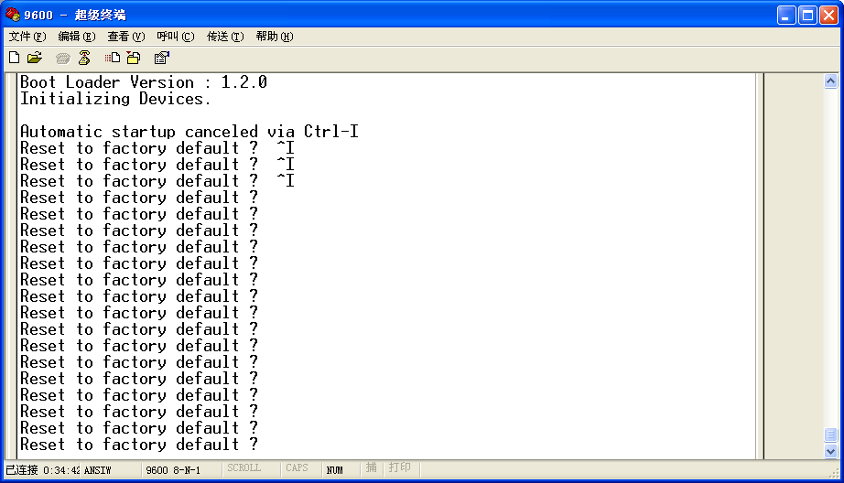
- input cmd: fmcifconfig eth0 -addr=192.168.131.20 -mask=255.255.255.0 -gw=192.168.131.1

na pc-ju tftp server v istem subnetu preveriti ping
firmware se ne unzipa
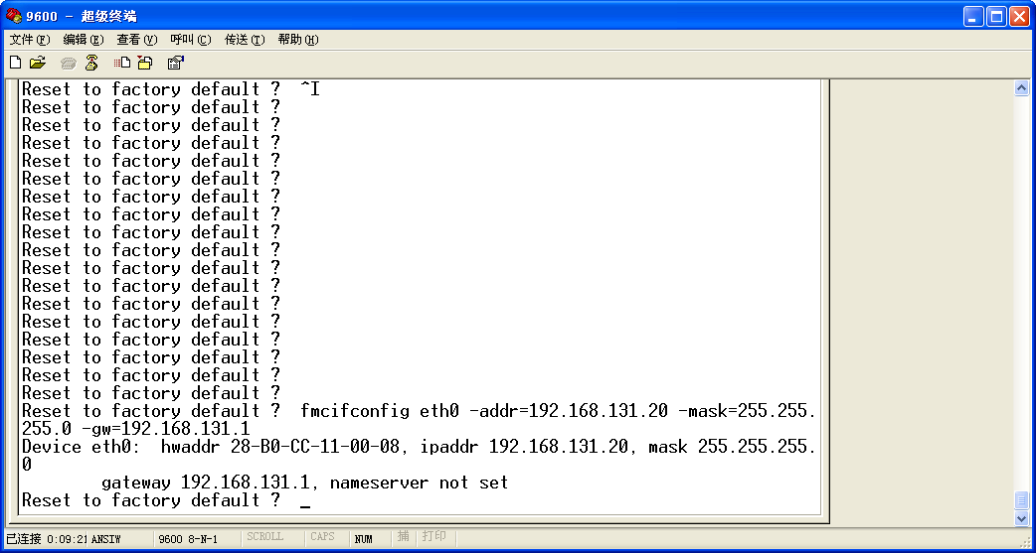
- input cmd: fmcflash -noheader 192.168.131.242:vm8224v111.gz flash0.os
Namesto vm8224v111.gz vpises ime bootloaderja, novi je v113 – obvezno na flash0.os
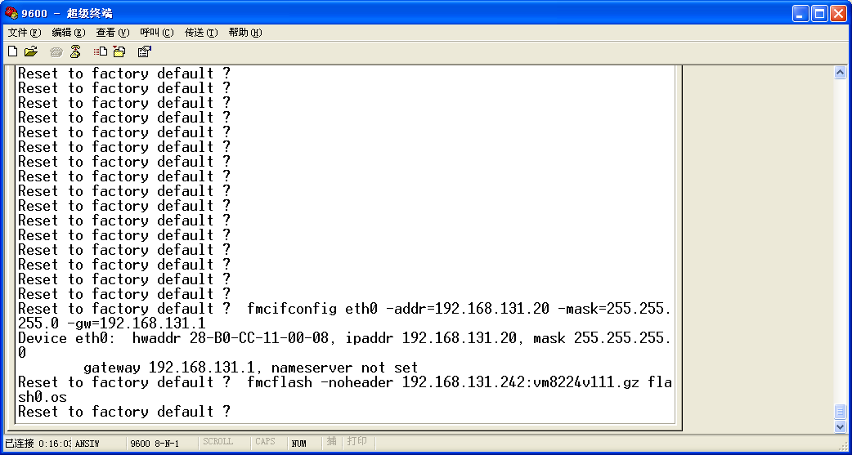
- input cmd: fmcflash -noheader 192.168.131.242:M8224v1325 flash0.ramdisk
Na flash0.ramdisk gre firmware, jaz sem sel postopoma, nisem sprobal iz najnizjega na najvisji direktno.
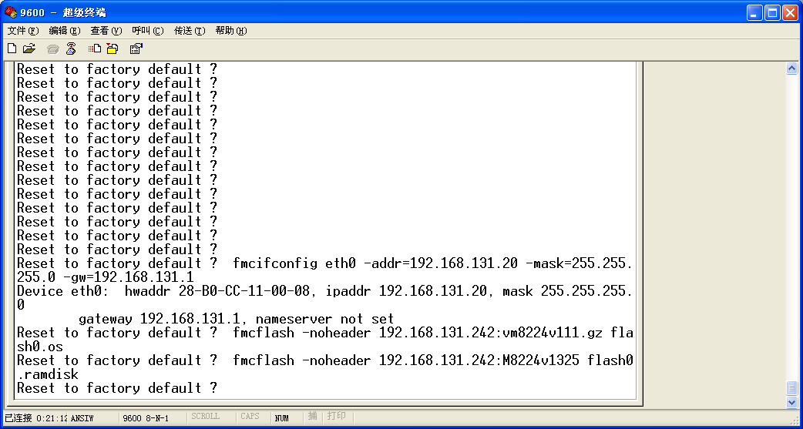
- exit or reboot the switch.

Navodilo velja za prehod na nov firmware do verzije kernela v113.
Po tej verziji upgrade gre online preko HTTP ali TFTP.

