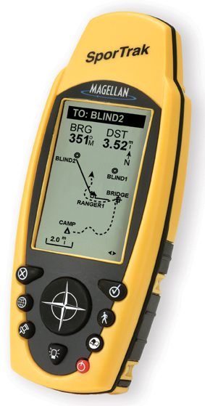SporTrak

Positioning
SporTrak is a feature rich, fun, and easy to use GPS receiver designed for everyone. The compact, rugged, waterproof, and ergonomic design makes it the perfect companion on that next outdoor adventure. The large and easily readable display, along with a front facing 9 key keypad makes it easy to use in any environment.

Included in SporTrak is a worldwide database of major city locations and 1 MB of additional uploadable memory for downloading points of interest from one of the DataSend line of CD-ROM’s.

SporTrak software includes 9 graphic navigation screens, storage for up to 500 waypoints and 20 routes, best fish and game time calculator, and BackTrack for finding your way home after a long trip into the woods. Add all this to a reliable, WAAS accurate GPS receiver making SporTrak the sportsman’s choice in handheld navigation.

Key Features
- Powerful 12 parallel-channel receiver
- WAAS enabled for up to 3 meter accuracy
- Quadifiler Helix antenna for superior tracking in harsh environments
- Worldwide cities location database
- 1MB of built-in memory for additional Point of Interest downloads
- 9 key keypad on front face for quick and easy access to software features
- Large display for easy map readability
- Rugged, waterproof design that floats
- Full featured software including 7 navigation screens

SporTrak

Specifications

Accessories

