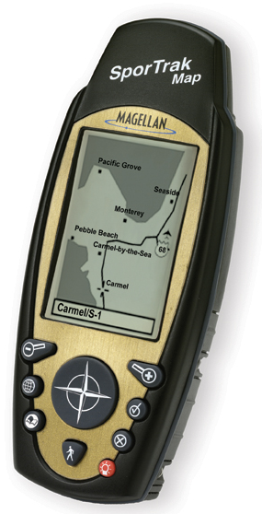SporTrak Map

Positioning
SporTrak Map brings built-in mapping and expandability within reach of everyone. It is a feature rich, fun, and easy to use GPS receiver that does not compromise on features at an unprecedented break through price. It has a small, rugged, waterproof, and ergonomic design that is perfect for the budget conscious outdoorsman needing a compact, but powerful navigator.

Included in SporTrak Pro is a European basemap of highways, parks, major waterways, and political boundaries. 4MB of built-in memory is also included for downloading detailed maps from one of the MapSend line of CD-ROM’s. Combine this with a large display and WAAS accurate GPS receiver, and SporTrak Map offers the same capabilities as other GPS receivers costing much more.

Key Features
- Powerful 12 parallel-channel receiver
- WAAS enabled for up to 3 meter accuracy
- Quadifiler Helix antenna for superior tracking in harsh environments
- 2MB European basemap of roads, waterways, parks, airports, and more
- 4MB of built-in memory for additional detailed map downloads
- 9 key keypad on front face for quick and easy access to software features
- Large display for easy map readability
- Rugged, waterproof design that floats
- Full featured software including 7 navigation screens

SporTrak Map
Specifications

Accessories

