PCB
Shape of external（Ｇ８）
（ｍｍ）

Base material : GE-4F (94V-0)
Board thickness : 1.6mm
Layer Number : 4 Layers
Copper leaf thickness : 18um / 35um / 35um / 18um
Measure : 39 × 60 mm
Conductor interval : Three between the pin
Surface processing : Solder Leveler
Solder register : Both sides
Silk print : White

Outline Drawings

Magellan P/N：701067-14 (Version 3)

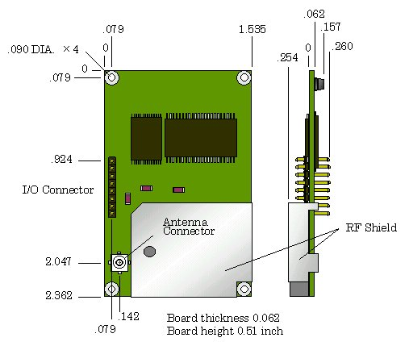

Magellan P/N：701067-12 (Version 1)

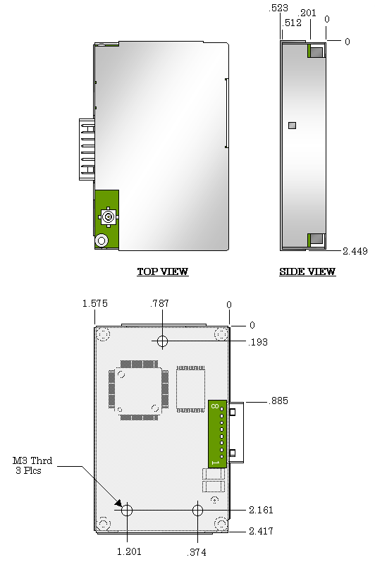
BOTTOM VIEW

Magellan P/N：701067-13 (Version 2)

