Adding the ProMark2 Antenna into Ashtech Solutions 2.x

Because the ProMark2’s antenna had not yet officially been tested by FGCS when version 2.5 was released, the antenna parameters are not in the program. Here is an easy way to add them in:

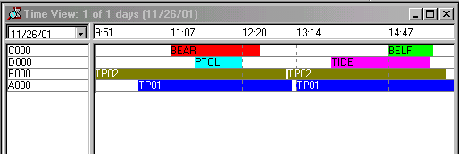(1) Open your Project in Solutions, and find the Time View Window (View, Time View):

(2) LEFT double click on any observation, in this case, the red one called BEAR. This brings up a box called Observation Properties:
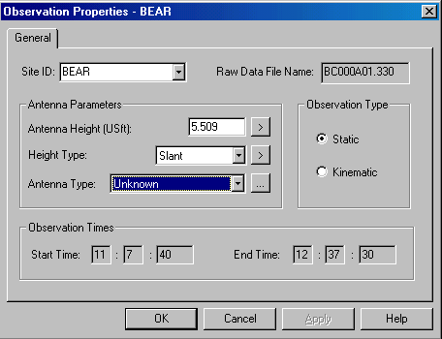
(3) To the right of the Antenna Type: Unknown section is a small box with three dots, please LEFT click on that box, which will bring up a box called Antenna Parameters:

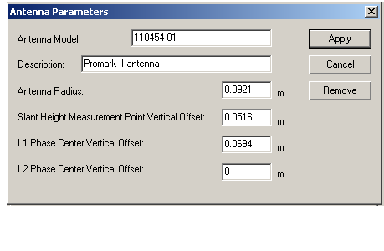

(4) Fill in the Box as shown, and click the Apply key, this will create a new antenna type for the ProMark2.

(5) Next, LEFT double click on all the remaining observations in the Time View Window. Make sure the Promark II antenna has been selected, and that the antenna height types and height values are absolutely correct.

