Test Procedure for Remote Control
and Data Download

- Establish communication remotely with a uZ CGRS using the standard procedure described in “Installing a Modem for Remote Control of the uZ”.
- The receiver must be powered to establish communications.
- Once the connection is established, select “View”, “Receiver Status”, “Receiver Information” to view the receiver’s basic information.
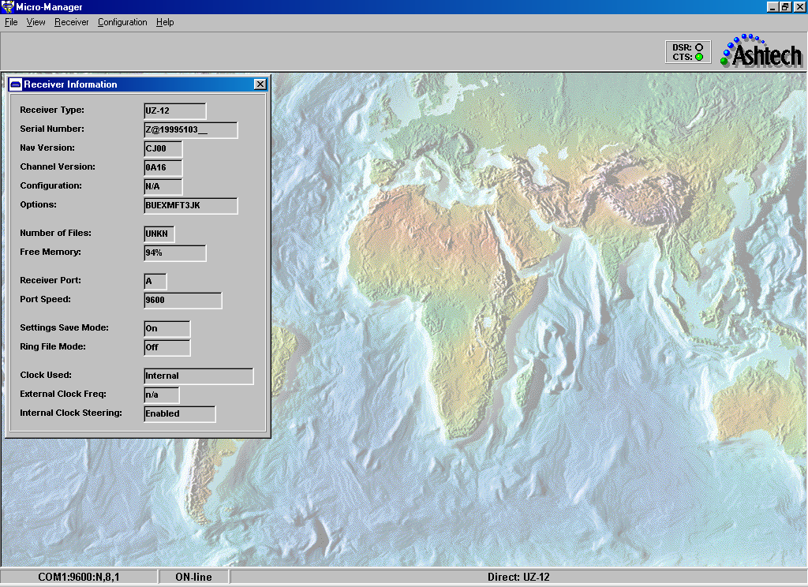
- Select “View”, “Receiver Information”, “Channel Summary” to view tracking status:
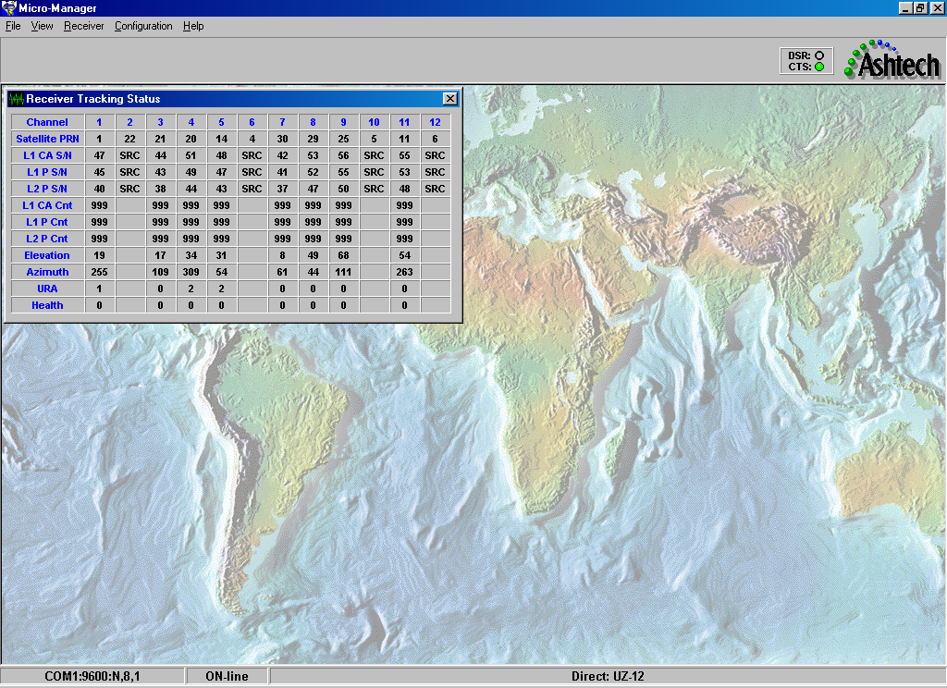

- Select “View”, Receiver Information”, RTCM Status” to display the DGPS status screen:
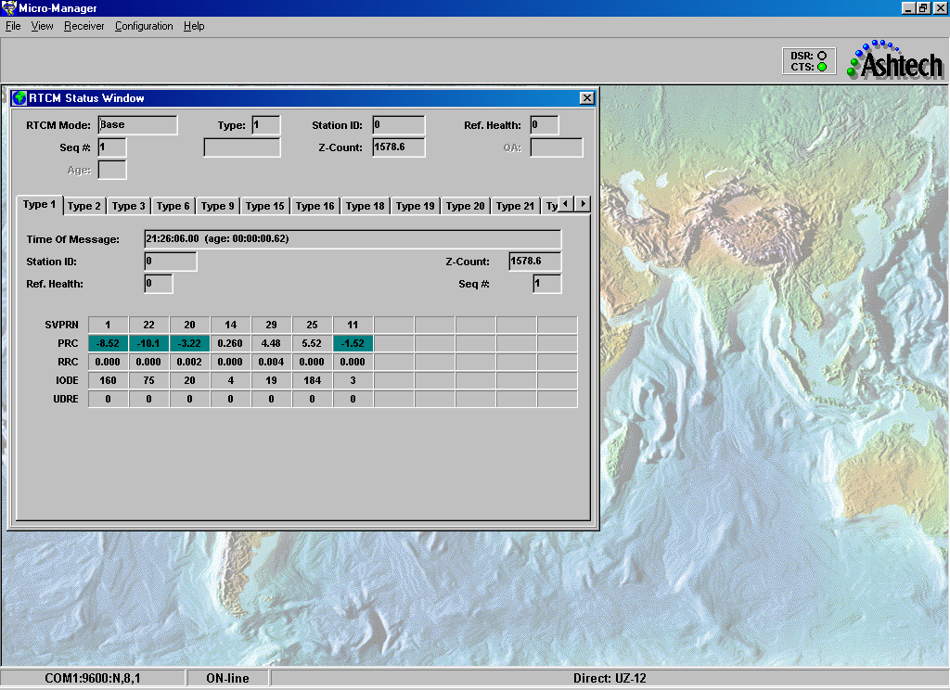

- Select “Receiver”, “Settings”, “RTCM Setup” to change the RTK broadcast setup parameters:
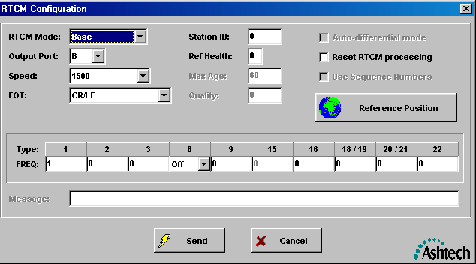

- Enter the Reference Position by pressing the button with the globe:
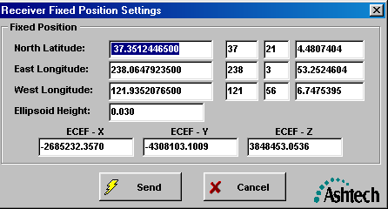

- Select “Receiver”, Settings”, “Program Sessions” to open the session programming window. If sessions are enables, right click anywhere in the sessions area and select “Delete all Sessions”:
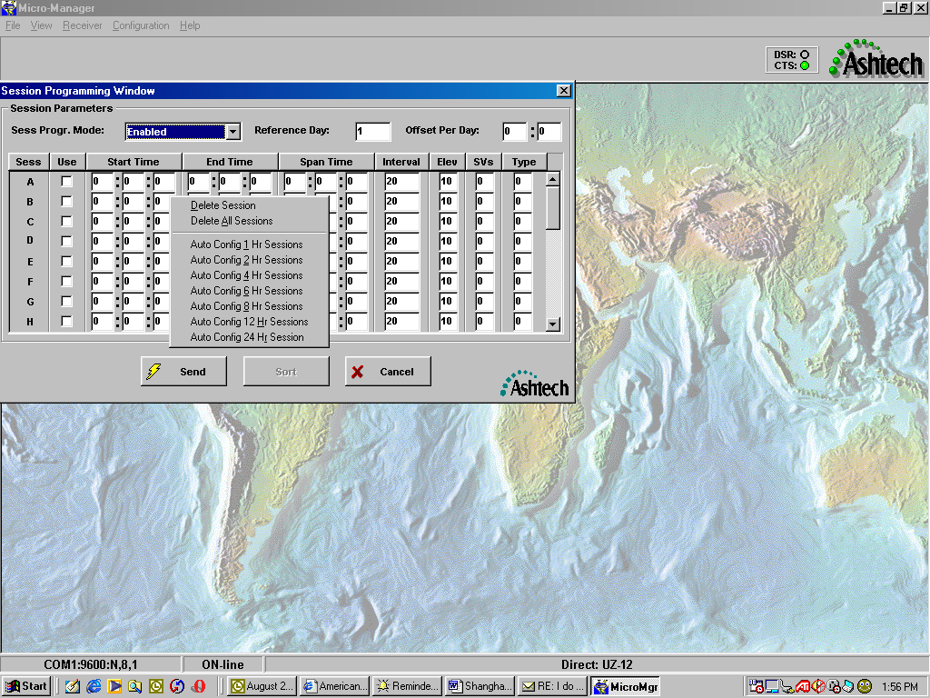

- Select a convenient start time in the near future such as hour 15 and enter this in the session A start time window. Enter a “span time” of 15 30 in the end time, enter the desired data rate (such as 20 seconds), enter the elevation mask if different from 10 degrees, and enter 4 for the SV column. Repeat this procedure for the next session, starting at the ending time of the previous session. Continue until 10 sessions are created. This will make the receiver create 30-minute files for 5 hours. Select enabled from the “Session Progr. Mode”, and enter a Reference Day of 1. Leave “Offset Per Day” 0. Check all the Sess boxes so that they will be used. The following should now be seen:
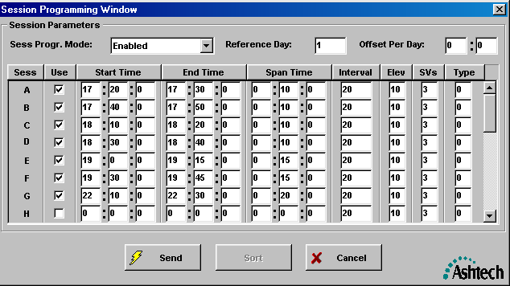

- Press the “Send” button to program the receiver.
Note: When Sessions are active, you cannot control the receiver recording parameters through the “Receiver”, “Settings”, “Recording Controls”. You must first disable sessions to access this screen. You need to access this screen to change the ring memory mode in the receiver if required. Ring memory should be “ON” for this application.
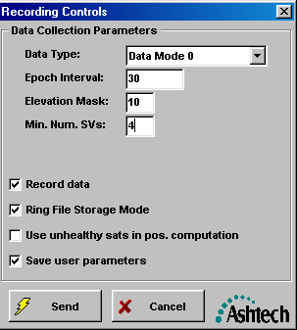

- Download data files by using the “Receiver”, “Files” menu item. A window will open showing all of the files on the receiver:
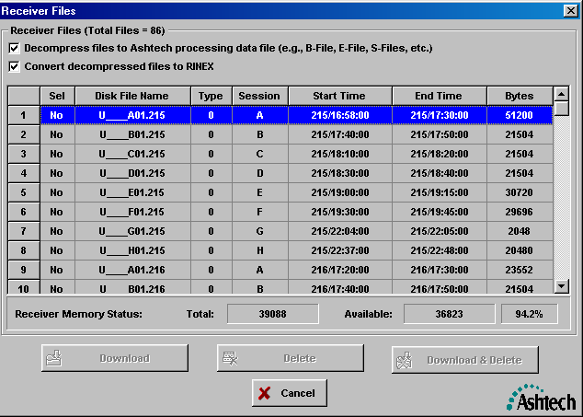

- To download a file, first set the output path for the data using the “Configuration”, “Miscellaneous”, “Output Path” option:
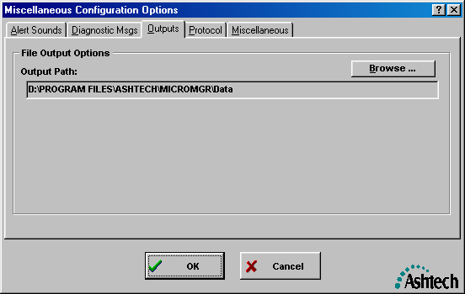

- Click on the “NO” field to change it to “YES”. Check the top two boxes to create B, E, and S as well as RINEX automatically after download. Click “Download and Delete” to retrieve the files:
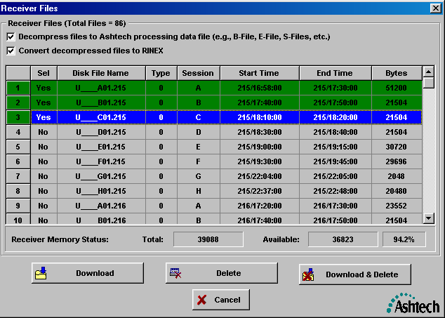

- View the files using Windows Explorer to navigate to the path where the data were downloaded.

