Installing a U.S. Robotics Modem for
Remote use of the uZ-CGRS with
Micro Manager Pro

When installing the uZ-CGRS for remote use with a modem, three Baud Rates must be considered. Baud Rate 1 is between the PC and Control Station modem. Baud Rate 2 is between the Control Station modem and the Remote location modem. Baud Rate 3 is between the Remote location modem and the uZ-CGRS receiver.

The following setup describes how these three Baud rates interact as well as the setup steps necessary when using a U.S. Robotic modem or similar Hayes compatible modem.

Step 1. Setup uZ-CGRS receiver.
- Attach the Modem Cable between Port A of the uZ-CGRS and the U.S. Robotics modem.
- Attach a Serial Data cable between Port B of the uZ-CGRS receiver and a computer to setup the receiver and initialize the modem.
- Attach the phone line to the U.S. Robotics modem and note the telephone number for the line.
- Initiate communication between the uZ-CGRS receiver and a serial communication package such as through the terminal window of MicroManager and issue the following commands:
$PASHS,MDM,ON,A,0,7<CR>
$PASHS,MDM,INI
- Confirm that after issuing the second command, the receiver responds with $PASHR,MDM,INI,OK
- Disconnect the computer from the uZ-CGRS.

You have now setup and begun communication between the uZ-CGRS and the Modem. Note that Baud Rate 3 has been set to 38400. The uZ-CGRS is ready to be called by a remote modem.

NOTE: You could skip issuing the command $PASHS,MDM,INI and just power cycle the receiver to force the receiver to initialize the Modem. It is recommended to follow the above example, however, the first time you hook the receiver to the modem in order to confirm that the initialization took place properly.

Step 2. Setup MicroManager Pro to dial the remote uZ-CGRS
- Attach the modem cable that either came with the modem or that you purchased separately to the modem and COM 1 of your Control Station computer. This is the Control Station modem mentioned in the introduction paragraph.
- Attach the phone line to the modem. Start MicroManager Pro.
- Configure Micro-Manager to use the U.S. Robotics modem:
  - From the “Configuration” menu select “Modem Settings”
  - Create a new modem configuration by clicking the “New” button.
  - Enter the modem name, for example “U.S. Robotics V Everything.”
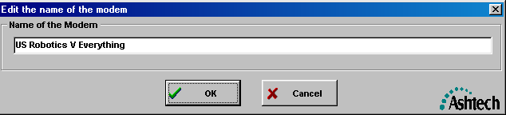
  - Leave the remaining settings at their default values. The screen should look like this:
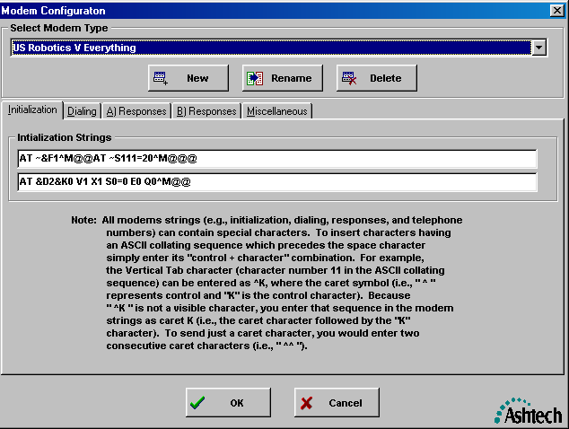
  - Press the OK button to close the window
- From the pull down menu “Configuration” choose “Phone List” and select the “New” button.
- The following screen should appear:

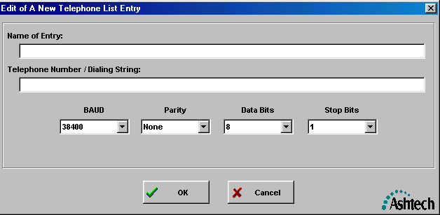
- Enter in the name of the Remote site you wish to communicate to in the “Name of Entry” window.
- Enter the phone number of the remote receiver’s modem in the “Telephone Number / Dialing String” window. The BAUD rate should be either 38400 or greater. You have now set up setting up BAUD rate 1.
- Press OK to save the dialing information for this site. The following screen should then be displayed (In this example we created “Example1” site at 38400.

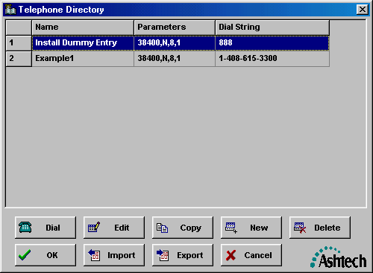
- Highlight the “Example1” line.
- Press the dial button at the bottom left of the telephone directory screen to communicate with uZ-CGRS receiver. Be sure the remote receiver has initialized its modem before initiating the call.
- Once the modem connects to the remote receiver, operation of the receiver is the same as with a direct connection from the computer.

NOTE: In the above example, the uZ-CGRS receiver was set to a BAUD of 38400 (Call this BAUD Rate 3, And the PC to Modem was also set to a BAUD rate of 38400 (Call this BAUD Rate 1). BAUD RATE 2 between the modems is typically determined by the 2 modems that are communicating with each other at the time of the call. It cannot be higher than the lowest setting of either BAUD rate 1 and BAUD Rate 3. Some older modems require that BAUD Rate 1 and BAUD Rate 3 be set the same.

