Ashtech Precision Products

Technical Bulletin

Date: October 6, 2000
Product: Promark X and X-CM
Subject: Overfull Memory/RAM Dump to PC
Number: 1

Summary: To describe the utilization of Log.exe to download files from the Promark to the computer when downloading function of Promark is no longer working.

 The Promark will shutdown the downloading process if the unit has collected too many files, thereby utilizing too much memory! The only way to retrieve these files is by using Log.exe, a DOS program which is available for free download from Ashtech’s ftp site, to collect a RAM dump from the Promark. Once the RAM dump is complete, you will need to go into the dumped file and manually cut-and-paste the data corresponding to the individual data files (not always easy, and somewhat time consuming).

The first step is to download Log.exe from ftp://ftp.ashtech.com/pub/software/mstar. This is the software that will allow you to dump your files from the Promark. Install log.exe on your hard drive, in a directory where you would like your Promark files to go.

The second step in “logging” is to connect the Promark to the computer through com port 1. SETUP7 and AUX5 will accomplish this task.

Next, start log.exe from the Windows directory by double-clicking on it. You will then be in the file menu. Check your setup to make sure com port 1 and Baud rate 9600 are selected. Press the ESC key to get back to the main menu, arrow up to LOG and press <enter>. The program will prompt you for a filename and an attribute. Give the file the same name as it appears on the Promark. Press <Enter> and the program will commence logging.

Now, turn on your Promark and enter SETUP 7 for Dataport selection. The screen shows PORT 1, press <Enter>. Use the right arrow key on the Promark to toggle to Log and press <Enter>. Now use the right arrow key to select 9600 BPS for the Baud rate and press <Enter>.

The final step is to press AUX 97 <Enter>, for data dump to Port 1.
Your PC screen should look like this:
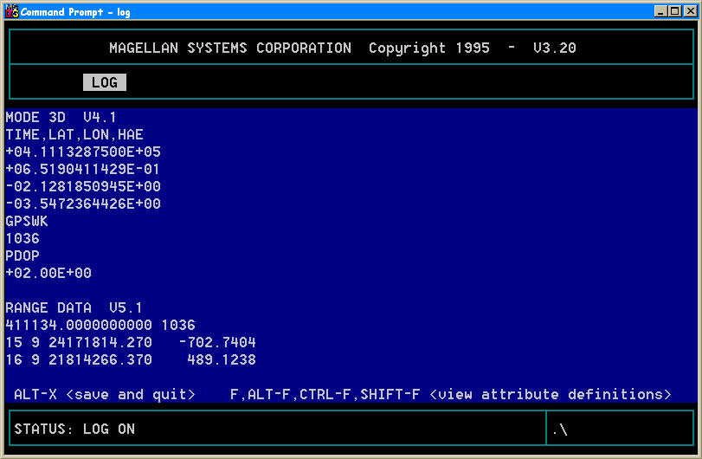

 This process is much more time consuming and tedious than the regular download process used in MSTAR. It is, therefore, most prudent to download and backup files at day’s end and return to the field with a full memory in the Promark unit each day.

