Application Note
Ashtech Z-12T Metronome

This note describes the use of a modified geodetic GPS receiver (Ashtech Z-12T Metronome) for the transfer of time between two remotely located precise clocks (atomic standards).

The Ashtech Z-12T is a specially modified Z-12 that is able to use a precise external oscillator (or clock) and 1 pulse per second (1 PPS) input in lieu of an internal crystal oscillator. Unlike the typical Z-12 arrangement for using an external frequency source, the Z-12T does not phase lock to the external oscillator but instead uses that oscillator directly. This leads to the requirement that the clock frequency must be converted to 20 MHz, the frequency required by the Z-12 internal circuitry. The 1 PPS input signal is used to define the 1-second points of the 20 MHz signal.

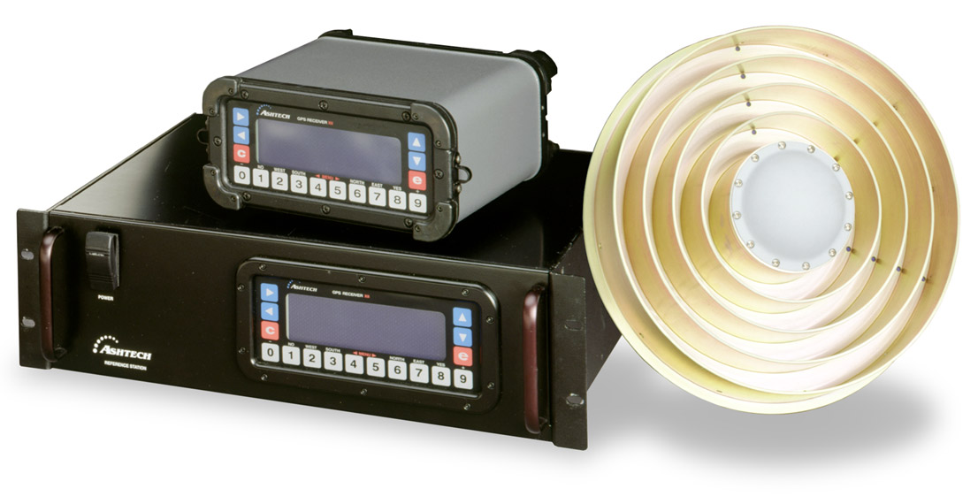
Figure 1 – The Z-12T Metronome

The Z-12T is available in two packaging options (figure 1). One is the original Z-12 package (P/N 99XXXX-10) and the other is a rack-mounted package (P/N 990341-10).

The Swiss Federal Office of Metrology and the Astronomical Institute of the University of Berne have incorporated Z-12T into the Geodetic Time Transfer terminal (GeTT). The receiver is housed in a constant-temperature box that was constructed by the Swiss (figure 2) to eliminate changes in internal delay due to temperature. Their receiver box also contains the 5 MHz to 20 MHz multiplier and a 1 PPS fanout. The GeTT also contains an Uninterrupted Power Supply (UPS), an industrial PC running Windows NT to control and download the receiver data and then push it via ftp to the processing center, and a Time Interval Counter (TIC) to compare the receivers 1 PPS in and 1 PPS out, thus measuring the internal receiver delay. (N.B., Magellan does not provide the temperature-controlled box developed by the Swiss Federal Office of Metrology).
The Allan variance of the instrument (σy(τ)) has been shown to be 10⁻¹³ at τ=100 sec.

Figure 2. Schematic of Geodetic Time Transfer (GeTT) terminal

To compare two clocks at remote locations, the clock at each site is connected to a GeTT terminal. The Ashtech Z-12T is connected to its choke ring antenna using RG-316 cable since this has been shown to exhibit very stable delay with temperature variation. The data are collected at a 30-second epoch rate and sent via ftp to an analysis center (the Center of Orbit Determination in Europe or CODE has been used by the Swiss group). At the analysis center, the data are processed following the creation of the precise orbit files, which takes a few days. The CODE processing estimates the station clocks at each site, thus providing the comparison of the two clocks.

F. Overney, et. al, “GPS Time Transfer Using Geodetic Receivers: Middle-Term Stability and Temperature Dependence of the Signal Delays”, Proc. 7th EFTF, 1997.
G. Dudle, et. al, “First Results on a Transatlantic Time and Frequency Transfer by GPS Carrier Phase”, Proc. 30th PTTI, 1998.

