

Engineering Update

Aquarius 01-02

Aquarius²11-12-22

Sagitta 01-02

July 2002

Application firmware (PC Board)

UCIMV20009

- TABLE OF CONTENTS

- 1. Table of Contents
- 2. Introduction
- 3. Equipment concerned
- 4. Version index
- 5. Enhancements
- 6. Compatibility
- 7. Equipment required
- 8. Step-by-step procedure
- 9. Attached items

- INTRODUCTION

THALES NAVIGATION makes every effort to satisfy its clients by regularly releasing enhanced versions of its products. The object of this document is to provide all the instructions required for updating any equipment already in use in the field so that users can benefit from the new enhancements.

- EQUIPMENT CONCERNED

Product line : Marine
Product : Aquarius01/02-Aquarius²11/12/22-Sagitta01/02
Sub-part : PC Board.
Firmware : ☑
Software : □
Hardware : □

- VERSION INDEX

UCIMV20009
- ENHANCEMENTS

- HM_Link Modules (HF/MF) compatibility but no HF decryption operational with this version.
- Raw data available from keypad.
- Automatic base station selection.
- Navigation function including left and right indicator and graphic display.
- Setup parameter and control display for fix or moving (Relative) base station.
- Display of received satellites for secondary antenna.
- DOP and LPME available.
- WAAS/EGNOS fix capability

- COMPATIBILITY

There is no hardware or software incompatibility of any sort with the other parts of the equipment. But to get complete benefit of all improvements, it is advisable to check you receiver hardware/software versions. After completing the update, the different versions in the equipment should be as follows:
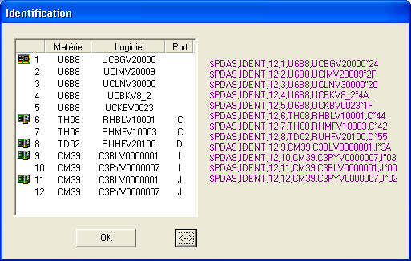

Configuration for Aquarius²22 with one U_LINK module and one HM_LINK module.

NOTICE :

Only CONFIGPACK (version ≥ V3.33) can be used to modify the internal configuration.
Former Confpack used for 5000 and 600 series for this new product line cannot be used

- EQUIPMENT REQUIRED

- A PC computer using WINDOWS95, 98 XP, NT or Millennium
- A PC to receiver serial line cable ( Part No.: 101243A) and RS422/232 converter ( Part No.: 2699075675AC).

- STEB-BY-STEP PROCEDURE

Using Softloadexe software

Software and Firmware are available on ftp site. Address ftp://ftp.ashtech.com/

8.1 Installing SOFTLOAD V2.0 software on your PC’s hard disk.

Run Install-SoftLoad-V2.0.exe and follow instructions.

8.2 UNZIP UCIMV20009.ZIP file.

- 3 Unzipped files are :

File name | Date (dd/mm/yy) | Size (bytes)
Thales.def | 08/07/02 | 1158
UCIMV20009.sfl | 08/07/02 | 222
UCIMV20009 | 08/07/02 | 3 965 555

8.3- Firmware loading

- Copy the Thales.def. file to the “products” directory of Softload.
- Copy the UCIMV20009 (no extension) and UCIMV20009.sfl files to the “release” directory of Softload.
- Connect A port of the receiver to RS232 port of your PC
- Switch on the receiver
- Run the SOFTLOAD Software from the task bar ( Start/Programs/ Thales Navigation /SoftLoad)
- Prior upgrading the receiver firmware, you must change a paramater in softload.ini file
- Exit from SOFTLOAD software and open the softload.ini file located in Windows directory for Windows95/98/XP or in WinNT for Windows NT/2000
- Modify the line Reserved 3=7 to Reserved 3=15 in [Miscellaneous] block and save the file
- Run again SOFTLOAD Software from the task bar ( Start/Programs/ Thales Navigation /SoftLoad)
- On the File menu, select Open, choose the UCIMV20009.sfl file then click Open
- Check data communication between the receiver and the PC by clicking the ? button on the toolbar. If communication is established, a window will open listing the different versions currently installed in the unit. In that case, close this window. If instead of the window, you get an error message, check the connections (data and power cables) and communication parameters. Unless these parameters have intentionally been changed earlier, they usually are the following: 9600 Baud, 8 data bits, 2 stop bits and “no parity”
- To start re-loading, click the red arrow on the toolbar. Note that the time of re-loading is about 10 minutes

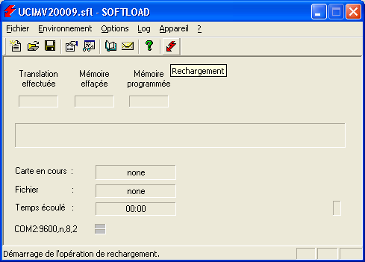

NOTICE: At the end of transfer SOFTLOAD software checks to see if the firmware has been correctly loaded then displays the new firmware status

SECURE mode
If during firmware loading either the receiver or PC supply shuts down it is not any more possible to establish dialogue.
The “secure” mode, selectable in receiver menu of Softload, is used to restore dialogue with the receiver.
Firmware re-loading then becomes possible.

- ATTACHED ITEMS

Items | Version / name | Date (dd/mm/yy) | Size (Bytes)
SOFTLOAD Software | Install-SoftLoad-V2.0.exe | 07/04/02 | 2 658 714
ZIP File UCIMV20009.ZIP | UCIMV20009 | 10/07/02 |  | 1 411 727

