JWD1000 Detector type Min Series Optical Power Meter
New in 2008
JWD1000 Min Series Power Meter equips with wide angle detector, replaceable attenuator and various fiber adapters, which can be connected directly with the computer with USB or RS232 communication port. It is an intelligent but economical test device and very suitable for optical power measurements from Passive Components Producers, Research Lab and University Lab.

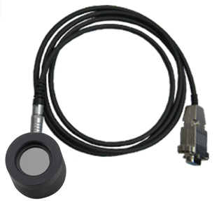
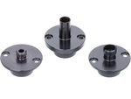
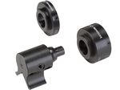
Various optical fiber adapters and attenuation chips can be used upon actual requirements.

Product Features
- Wide angle Si、Ge detectors can be alternative
The JWD 1000 min series OPM can support the detector size up to 5mm for Ge detector and 10mm for Si detector.
The measurement wavelength range is from 400~1100nm for Si detector and 800~1600 for Ge detector, with dynamic ranger of 60dB.
- Compensation of the detector temperature
JWD1000min series OPM can calibrate the value of the testing result trough the detector temperature compensation; this will lessen the reading value offset caused by the external temperature change
- Various Optical Fiber Adaptors can be required
JWD1000min series OPM provide the FC, SC, ST, LC and other kind of changeable optical fiber adaptors, can adapt for all kinds of the need of the optical fiber connection.
- User-self Calibration Function
Any wavelength can be calibrated by user independently (up to 9 wavelengths calibration can be supported). The device do not need to send back to the original factory for recalibration, it can be deal with in the local Measurement Bureau for the annually calibration.
- Attenuation Chips can be changeable
JWD1000min series OPM support 10,100 and 1000 absorbability attenuation chips, for the convenience of users’ variable attenuation requirements.
- WIN32 API Support
JWD1000 min series OPM provide various API ports based on WIN32, so that the user can develop its own software according to its actual requirements, which includes:
- Data Reading
Read the current wavelength power value (also can customize the relative log, absolute log, and linearity), also can read the detector temperature
2) Calibration
Calibrate the current wavelength, zero calibration, and adjust the compensation temperature
3) Setting
Setting the wavelength, Setting the measurements mode (manual, Auto), Setting the ranger, Setting the filter speed, Setting Units, Setting the reference value

JWD1000 Detector Type Min Series Optical Power Meter
New in 2008
Product Specifications
Model | JWD1000 mini Series OPM
Wavelength (nm) | 400～1100(Si); 800~1600(Ge)
Pre-determined  calibrated wavelength (nm) | 850/980/1300/1310/1490/1550/1625（Ge Detector）；660/780/820/850（Si Detector）
Self-calibration wavelength qty | 9 Max
Uncertainty（Full rang） | 5％
Dynamic Rang（dB） | 70
Unit | Linear：nw、uw、mw、w  Log：dB、dBm
Displaying speed（Data average） | SLOW：960ms（16 times on average）  MEDIUM：480ms（8 times on average）  FAST：60ms（uneven）
Resolution | 0.001
Communication Port | Standard RS232 Port or USB port
Cable length | 1.5m（Standard）or Customized
Operation temperature (℃) | ＋10~＋40
Storage temperature(℃) | - 20～＋60
AC adaptor | 9V DC/RS232 or supply by USB cable
Warm-up time | 20Min.
Weight(kg) | <200g
Dimensions(mm) | Ǿ45×40

Ordering Information
Model | JWD1000-A-B-C-D-E mini Power Meter
Detector Type（A） | - 3mm Ge -60~0dBm  - 5mm Ge -60~0dBm  - 5mm Si -60~0dBm  - 10mm Si -60~0dBm
Communication port （B） | - RS232  - USB
Cable Length（C） | - 2m（Standard）  - 5m (Optional)
Attenuator type（D） | - 10 time absorbability attenuation chips (+10~-60dBm)  - 100 time absorbability attenuation chips (+20~-50dBm)  - 1000 time absorbability attenuation chips (+30~-40dBm)
Adaptor Type（E） | - FC  - SC  - ST  - LC  - Bare Fiber
Remark：1、Each attenuation chip is unique relative to the detector.
2、Extra calibration service can be optional on customer requirements
Standard Packages
Model | include
JWD1000 mini series  Optical Power Meter | Main Unit, RS232 communication cable, FC Adaptor, A piece of Attenuator, AC adaptor, Software CD, Cotton Tampon, User manual.

JW3201N Bench-top optical Power Meter
New in 2008
JW3201N Bench-top Optical Power Meter is a high precision and wide measurement range test instrument which designed specially aim at passive components factories, R&D institutions and universities. With features of accurate measurements, durable use and easy operation, JW3201 N Bench-top Optical Power Meter becomes a perfect test equipment in fiber optic works which can instead the advanced imported products with its high cost-performance ratio.
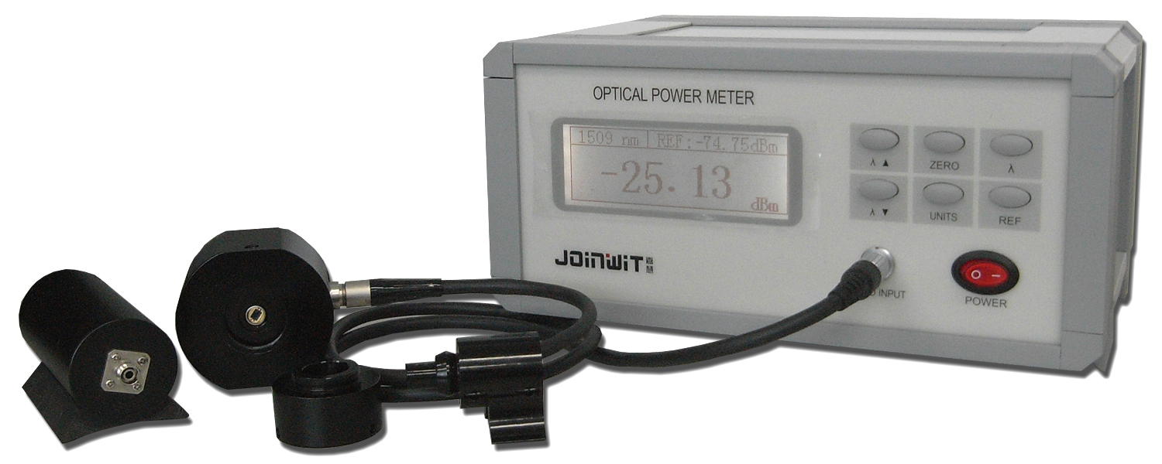

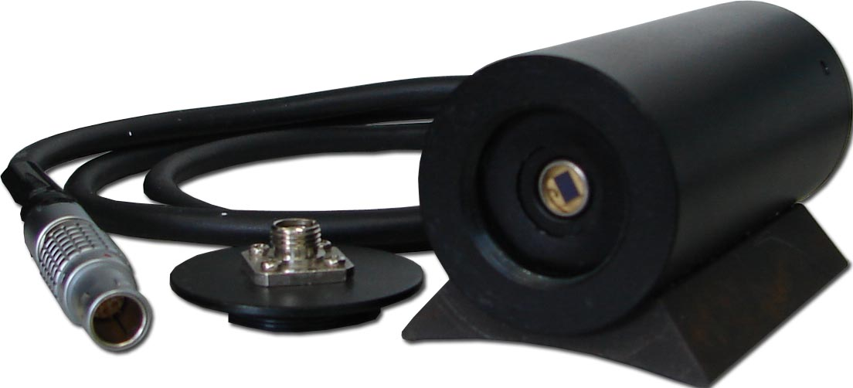
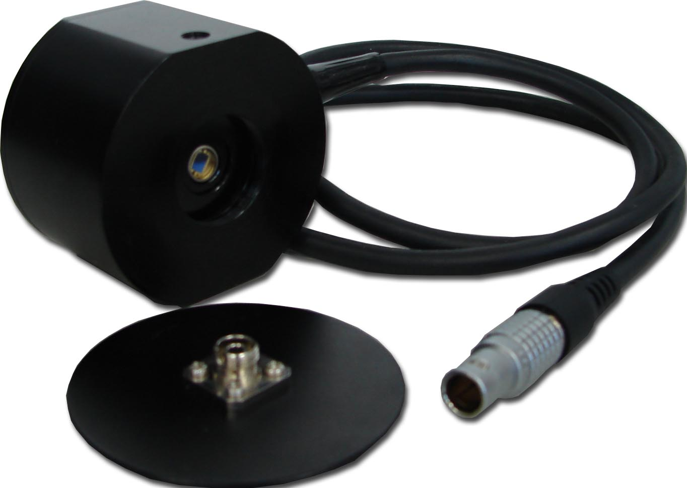
JW3201N1 Horizontal detector

JW3201N2 Vertical detector

JW3201N External Detectors Introduction (Refer to right pictures)
- JW3201N1 Horizontal detector:
With 2.0mm Photosensitive area, 0dB InGaAs
- JW3201N2 Vertical detector:
With 3.0*4.0mm Photosensitive area, 0dB TO detector
- The only tip for bare fiber can be optional
- Different external detector can be used on customer requirements

The only Tip for bare fiber
JW-430 bare fiber tip have a V sharp slot, the bare fiber can pull in and out and orientation repeatedly. And it can protect the fiber against the pressure from outside, to avoid fiber tortuosity that will cause the polarization dependent loss. JW-430 can fully encircle the bare fiber, to against the surrounding light come into the fiber, to make the test result more preciously.
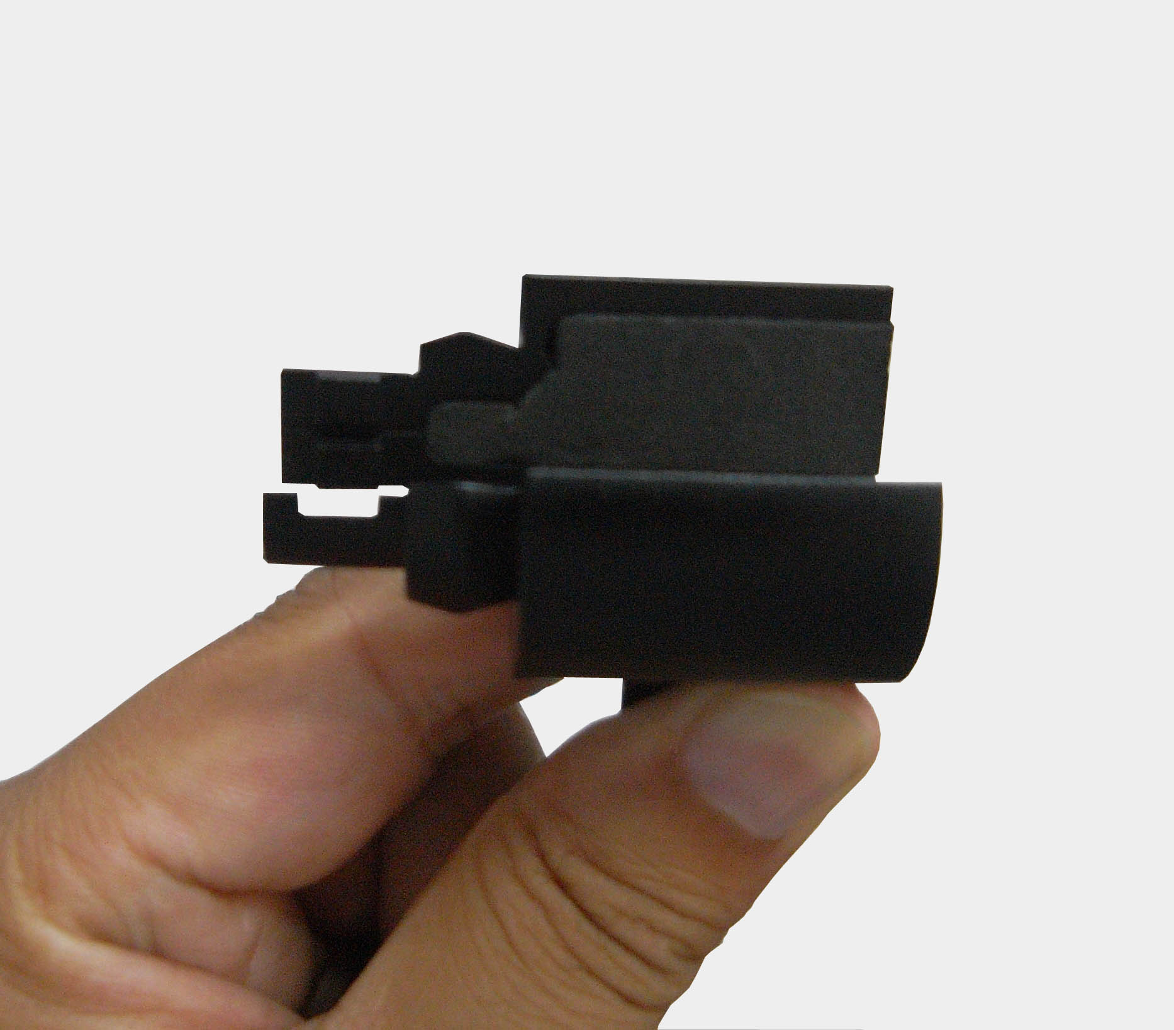
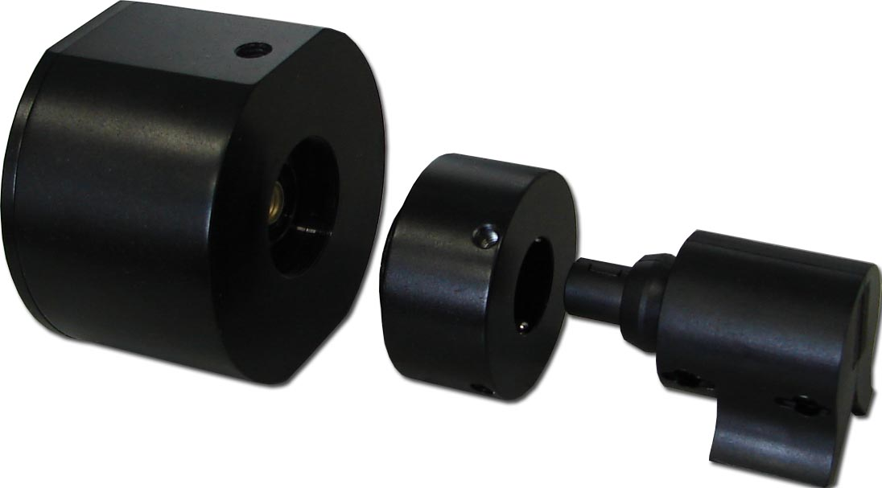
V Sharp Slot

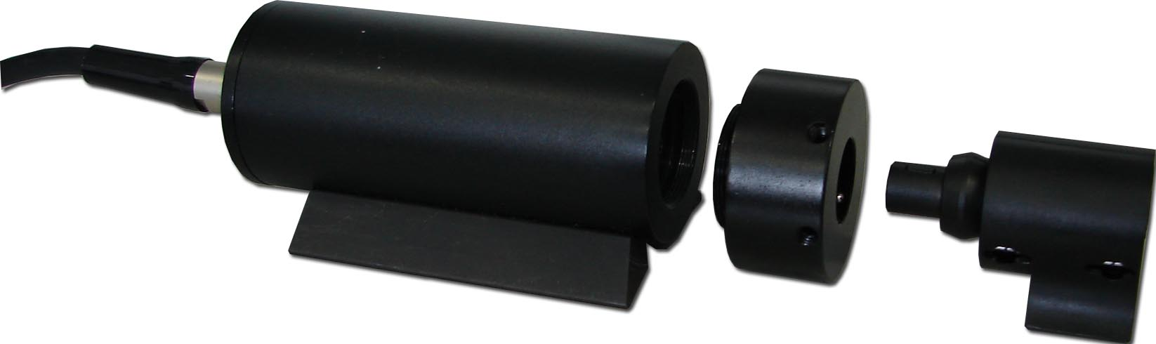

N1 type detector or N2 type detector can be matched with JW-430 bare fiber tip
Product Features
- External detector makes the testing operation more convenient.
- 850~1700nm wide wavelength range, wavelength can be adjustable in 1nm increments.
- High accuracy, the uncertainty is±3％
- Display resolution 0.01dB
- Wide Power Measurement range (+5～-75dBm)
- User self-calibration function
- “Ref” setting enables the user to retrieve and display the measurement that has been stored as a reference. Link loss test result obtained automatically without any manual calculation.
- Adopt the new Data Acquisition technology to ensure optimum signal-noise ratio.
- Use the bare fiber tip to realize power measurement with bare fiber
- Enables data transfer to a PC via RS232 communication port as well as data storage automatically.
JW3201N Bench-top optical Power Meter
New in 2008
Through communication with RS232 port and PC, can realize the optical power monitoring without people, as well as displaying the data on the instrument and the PC at the same time
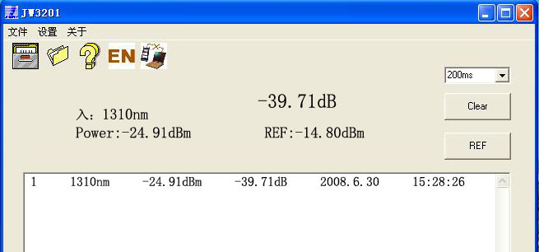
PC Displaying Interface

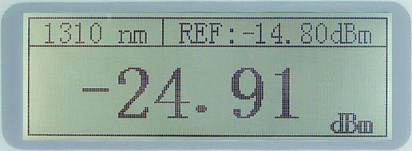
Instruments Displaying
Interface

Product Specifications

Type | JW3201N
Wavelength Range(nm) | 850～1700 (in 1nm increments)
Calibrated Wavelength(nm) | 850，980，1300，1310，1480，1490，1550，1625
Photo Detector | In GaAs
Measurement Range (dBm) | +5～-75dBm (other measurement range can be customized)
Intrinsic Uncertainty | ±3%
Communication interface | RS232
Resolution(dB) | 0.01dB
Optical Connector | FC
Power Supply | AC90～260V，50Hz
Operating Temperature (℃) | -10~+40
Storage Temperature (℃) | -25~+70
Dimension(mm) | 260*190*120
Weight (kg) | 2.75

Ordering Information

Model | Description
JW3201N－X | 1. JW3201N 1 Horizontal detector  2. JW3201N 2 Vertical detector
JW-430 | JW-430 Bare Fiber Tip
Standard Packages

Model | Standard Package List
JW3201N1  Bench-top Power Meter | Main Unit,JW3201N1 horizontal detector, RS232 data transfer cable, Power supply Adaptor, Software CD, Cotton Tampon, User Manual
JW3201N2  Bench-top Power Meter | Main Unit, JW3201N1 horizontal detector , RS232 data transfer cable, Power supply Adaptor, Software CD, Cotton Tampon, User Manual

Bench-top Optical High Stable Light Source---------JW3102

Joinwit has designed the JW3102 Benchtop highly stable light source
specially used in manufacturing of passive optical components and in testing of lab research. Relying on the high accuracy automatic power control (APC) and the automatic temperature control (ATC) techniques, the JW3102 series light sources has very stable output power and wavelength. JW3102 can deliver 1 to 2 wavelengths upon customer request and laser types can be optional to satisfy customer’s various requests. It is an ideal test equipment for required conditions of widely varying attenuation, highly stable output power and wavelength.
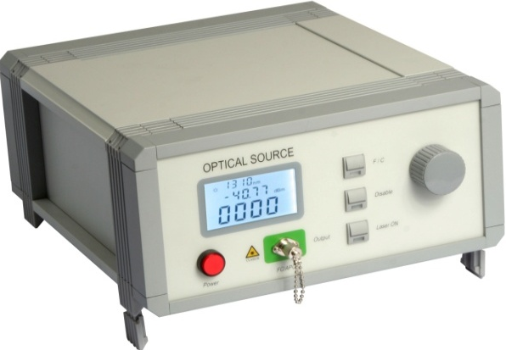

Features
- Optical Output Power can be adjustable, adjustment range can be custom-made according to the needs
- High stability and reliability
- High accurate ATC and APC control electrocircuit
- Many kinds of laser wavelengths, Customer order is available
- OLED display is employed to make a comfortable seeing.
- USB communication port

Applications
Manufacturing and Testing of Optical Passive Components
WDM Testing
Lab Testing
Testing of Stability and Linearity
Test instrument calibration
Communication System Test

Specifications
TYPE | JW3102-A(Single wavelength) | JW3102-B(Dua-wavelength)
Operating Wavelength(nm) | 850,980,1310,1480,1550,1625 | 1310/1550,1310/1480,1480/1550,980/1550
Optical Connector | FC/APC(Other type adapters can be cusomized)
-3dB Spectral Width(nm) | <0.1
-20dB Spectral Width(nm) | <0.5
Side mode suppression ratio(dB) | >35(DFB)
Optical Output Power(mw) | 1~10
Output power stability in 15 minutes(dB) | ±0.005
Output power stabiltiy in 8 hours(dB) | ±0.05
Internal Modulation Frequency | 270Hz,1KHz,2KHz pulsating wave, Dutyfactor 50±10%
external Modulation Frequency | Digitals Signals(frequency:DC~10MHz,TTL)
TEC stability | ±0.1℃
Operating Voltage | 85~264VAC
Power Consumption | <15W
Operating Temperature | -10~+60℃
Storage Temperature | -25~+70℃
Dimensions(mm) | 300*260*120
Net Weight(kg) | 3
Remark: All specifications stated here are depend on DFB laser, Specifications like emitter types, central wavelength, output power on demand.

Standard Packages
MODEL | INCLUDES
JW3102 all models | JW3102 Optical Light Source,Power Suppy Cord,Fuze, Instruction Manul and Cotton tampon.

ASE Broadband Light Source--------JW3107

JW3107 ASE (Amplified Spontaneous Emission) broadband light source
is designed specially for manufacturing of passive optical components and for testing in lab research. The main body of the light source is composed of high-powered pump laser and erbium doped fiber. Inimitable ATC and APC circuits are used to ensure the stability of the output power. The output power can be adjustable in a certain range by adjusting the APC. The JW3107 broadband ASE light source can operate in the C band, the L band as well as in the C+L band.

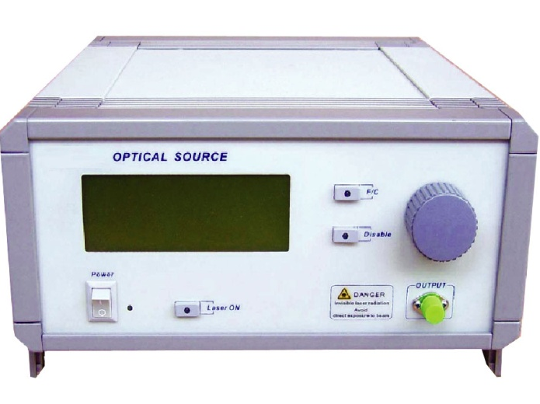
Features
- Hight output power, the max. power can be 100 mw.
- Wide operating bandwidth, covering C-band and/or L-band
- Excellent flatness within spectrum range
- Intelligent micro processing system and long distance control
- High stability and reliability
- Highly accurate ATC and APC control electrocircuit

Applications
Manufacturing and Testing of Passive Optical Components
WDM Testing
Manufacturing and Testing of EDFA
Lab Testing and Fiber Optic Sensor Systems
Other Optical Fiber Engineering Applications

Specifications
MODEL | JW3107
Wavelength Band | C+L Band
Operating wavlength | 1525~1610nm
Output power | >17dBm
Spectrium Density Stability | ±0.05dB/15min
Output power stability in 15 minutes | ±0.02dB/15min
Output power stabiltiy in 8 hours | ±0.05dB/8hour
Flatness | 10dB
Output return loss | >45dB
TEC stability | ±0.1℃
TEC operating range | 25±5℃
Operating Voltage | 85~264VAC
Power Consumption | <15W
Operating Temperature | 0~45℃
Storage Temperature | -40~+80℃

Standard Packages
MODEL | INCLUDES
JW3107 all models | JW3107 ASE Broadband Light Source,Power Suppy Cord,Fuze, Instruction Manul and Cotton tampon.

Insertion Loss and Return Loss Test Station----JW3307A

JW3307A Insertion Loss/Return Loss Test Station

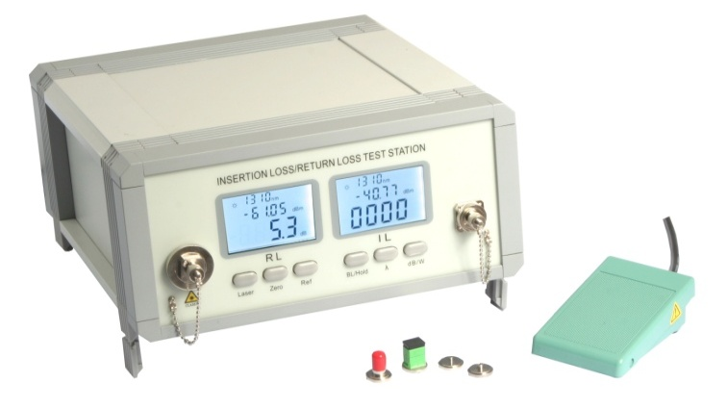
is a high performance loss test station that is designed specially for Optical Passive Components production Test and Lab Test. It combines three different working modes as a return loss meter, optical power and loss meter and a stable laser source in one test station. It features:
- High measurement accuracy
- Accurate analysis to wide dynamic ranger and weak signal
- Two LCD displays used, efficiently reduced eye strain of operators
- Leakage design of optical power meter module and light source module, obviously reduced operation procedures.
- Movitable optical connector set design, easy to clean
- USB Port design, enables data trasfer to a PC via USB port .

Specifications
Model | JW3307A
Optical Return Loss Test
Wavelength | 1310/1550nm
Optic Connector | FC/APC
Return Loss measurement Range | 0 ~ 75dB
Calibrated wavelength | 850/1300/1310/1550nm
Output Stability of laser source | 0.05dB(1 hour@250C)
Measurement accuracy | 0.25dB
Resolution | 0.01dB
Optical Power and Loss Test
Wavelength Range | 800~1700nm
Calibrated wavelength | 850/1300/1310/1550nm, more other wavelengths can be optional
Optic Connector（Power Meter） | Interchangeable FC/SC/ST/2.5mm Universal /1.25mm adaptors
Photo detector | InGaAs
Display modes | dBm/dB/xW
Measurement range | +3 ~ -80 dBm
Resolution | Non-linear 0.001dB ；Linear：0.001nw/µW/mW
Measurement accuracy | 0.25dB
Other Specification
Communication Port | USB
Power Supply | AC 90-260V，50～60Hz
Operation Temperature | -5℃～+55℃
Storage Temperature | -25℃～+70℃
Dimensions | 300X260X120mm
Weight(kg) | 3

Standard Packages
MODEL | INCLUDES
JW3307A | JW3307A Main Body, Power Supply Cord,FC Adaptor,SC Adaptor, ST Adaptor,  25mm Universal, 1.25mm Universal Adaptor,Instruction Manual,FC/APC-FC/APC patch cord  FC/APC-FC/PC patch cord, Cleaning Cotton Swab, Fuse, USB Cable(Optional),  PC software (Optional), Foot Peda (Optional)

