



Product manual
Trademarks
All trademarks are property of their respective holders.

Consequential Loss and other possible losses

HyperOs Systems Ltd shall not in any circumstances be held responsible for any consequential losses or any other losses suffered or deemed to be suffered or claimed to be suffered by User, including, without limitation, data loss or data corruption or loss of profits.

3 Year RTB Guarantee

Within the first 3 years after delivery of the HyperDrive unit to the Customer, if a fault develops in the HyperDrive unit which fault is not attributable to misuse of the unit, and which fault is not attributable to abuse of the unit, then if the unit is returned to the offices of HyperOs Systems, then HyperOs agrees to fix or replace any defective HyperDrive Technology as soon as is reasonably practical and technologically feasible.

The information provided in this manual is subject to change without notice.

Handling procedures


Please observe standard anti static procedures when handling the HyperDrive4 and memory sticks for the same. Make sure that the power to you Motherboard is switched off before you connect or disconnect the HyperDrive. And make sure that the power to the HyperDrive is disconnected before you insert or remove any memory modules.

CAUTION

Product Layout
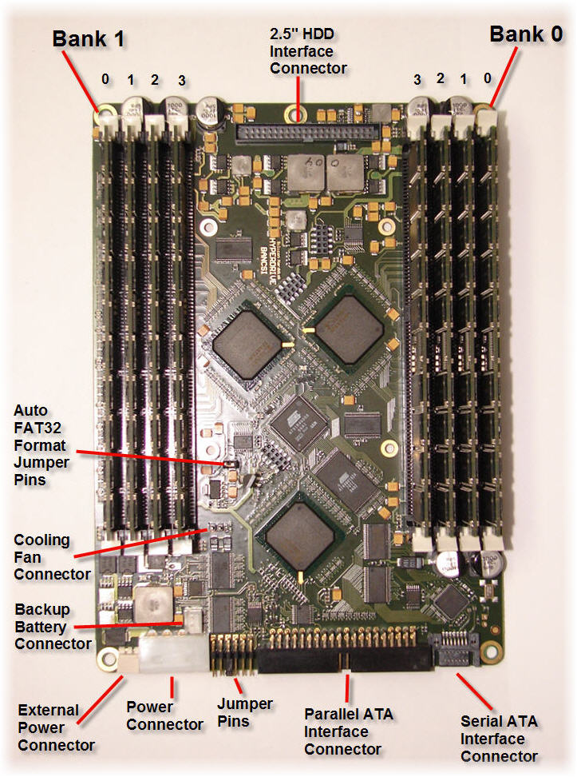

Jumper settings

The HyperDrive4 is equipped with 6 jumpers.

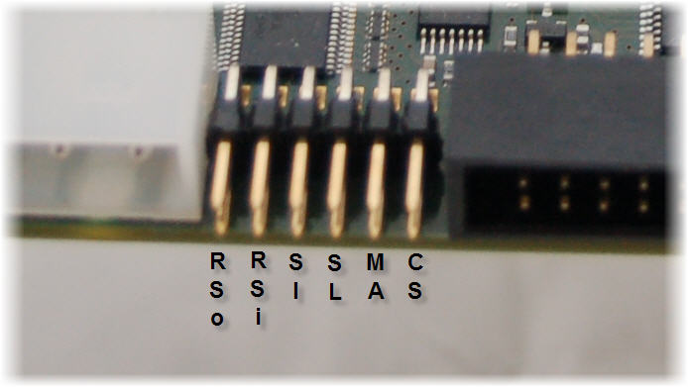

From right to left we have:

CS : Cable Select,
MA : Master,
SL : Slave,
SI : Single Device,
RSi : Reset Input (for portable HDD backup)
RSo : Reset Output (for portable HDD backup).

The CS, MA and SL are like any other hard disk. When the jumper is set to Single device mode, the HyperDrive4 indicates to the system that it is the only device connected to the cable, therefore your computer will not wait for any Slave device to present, this speeds-up system boot time.

Auto Format

The HyperDrive4 has an auto-format option, which automatically formats the HyperDrive4 as FAT32 Logical. This option is enabled when the Auto-format jumper is connected. You can manually reformat the thing as NTFS Primary in seconds if you so wish.

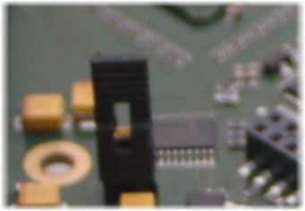

Memory Modules

The HyperDrive4 can hold up to eight 3.3V 184-pin Registered ECC DDR-SDRAM memory modules. The HyperDrive4 has two memory banks named bank0 and bank1. There are 3 rules!

1. Memory modules must be registered ECC DDR1 at least 1GB in size.
2. They must be inserted from the outside in.
3. All memory modules within one bank must be of the same type and model.

So, for example, one could have four 1GB Registered ECC memory modules of the same type and make in bank0 and a single 2GB Registered ECC memory module in bank1, forming a 6GB Storage device.

Inserting Memory

- Loosen the two screws at the back of the HyperDrive4.
- Gently pull back the back plate by 2 mm.
- Remove the top cover, by pushing your finger into the air duct in the back plate and pushing the top cover upwards with it.
- Disconnect the backup battery if connected.
- Carefully insert the memory modules by pressing them in the memory sockets, taking the requirements and conditions into account.
- Make sure all modules are fitted correctly by making sure all “white-handles” are in lock position. (Check by pushing each handle in lateral direction toward the module.)
- Reconnect the backup battery if required.
- Replace the top cover.
- Tighten up the back plate again.

Connecting the HyperDrive

- Turn off the computer and all peripheral devices, and disconnect the computer’s power cord.
- Remove the computer housing or casing. Place the Hyperdrive4 in a 5.25-inch bay.
- Secure the drive into the drive bay using four screws.
- Connect the 4-pin power cable.
- Connect either a UDMA (80-Conductor_ IDE/ATA cable or a SATA cable (not both).
- Remove an unused slot plate at the back of the computer casing and place the external power PCI back-plate in the vacant slot.
- Connect the external power back-plate power connector to the HyperDrive4 external power socket, next to the 4-pin power socket.
- Re-install the computer housing or casing.
- Connect the T shaped external power cord to the power supply of the PC
- Reconnect the PC power cord, to the T shaped external power cord.
- Connect the T shaped power cord to the external power converter, which supplies the PCI blanking plate socket with the DC external power for the HyperDrive.
- Turn the computer on.

Tips using the Hyperdrive

With external power disconnected, the HyperDrive will not lose data during a powered restart. It will only lose its data if you turn the PC off. With the external power connected the HyperDrive will only lose data during a long power cut. It can keep data alive during a power outage for a limited time span (a few hours) by virtue of a 7.2V battery. If data retention on the HyperDrive is important than you should back up the data on a schedule. If you are using the Windows platform you can use HBS2007 to achieve that. Alternatively you can connect a UPS to the external power supply of the HyperDrive. When internal power is lost the HyperDrive enters sleep mode where it merely refreshes its DDR. In sleep mode the HyperDrive draws around 1.5 amps at 9Volts.

To Boot or not to Boot

The simplest use of the HyperDrive 4 is just as an extra logical disk. But you can equally well use it as a primary boot disk. In the second case you should ensure that you have protection against power outages, unless you live in Switzerland!

HyperOs 2007

Windows users can install the HyperDrive as a Logical drive and use HyperOs 2007 to clone a copy of that OS from the Boot drive to the HyperDrive. Then they can choose to run Windows either from a hard disk or from the HyperDrive.

Back-up hard disk

The HyperDrive has 4 fixing holes for 6mm Motherboard spacers, which screw into a 2.5”” laptop Hard Disk. Any notebook Hard Disk can be fitted on to these spacers. We factory fit either a mechanical 2.5” drive or a flash 2.5” drive on request. The backup drive is connected to the HyperDrive via a 2.5” IDE cable to a 44 pin header on the HyperDrive board.

The 6 hour battery sits on top of the laptop drive and should be attached with the Velcro strips provided.

With the battery and a 2.5” drive attached the HyperDrive becomes completely non volatile. In the event of a power outage the device runs off the battery for the first 10 minutes (since many power outages last less than 10 minutes or perhaps the user may wish to disconnect the HyperDrive form one PC and connect it to another PC within 10 minutes without having to wait for an autobackup and an autorestore). During this 10 minute period, the internal HyperDrive activity LED will flash every 5 seconds.

Then after 10 minutes the autobackup kicks in and the DDR data is copied to the 2.5” drive. This process takes around 5 minutes for 16GB of data. During the backup the internal activity LED is on continuously. After the backup is completed, is it flagged as valid, and if power is still absent, the device shuts down and waits for power to be restored.

When power is restored, the HyperDrive automatically restores the image from the 2.5” drive back to the DDR. This process takes around 5 minutes for 16GB of data. The HyperDrive will only autorestore if it detects a valid image on the 2.5” drive.

