Secure Computing / F5 Partnership FAQ

November 15, 2006
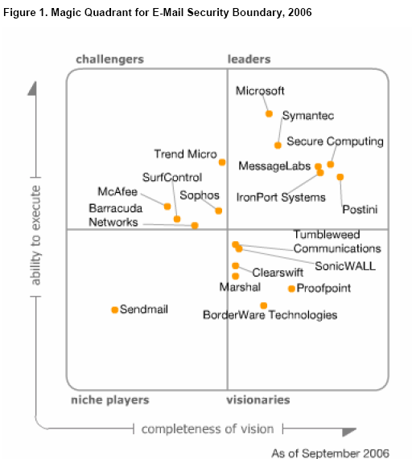

What is this new partnership all about?
F5 has contracted with Secure Computing (formerly CipherTrust) to license their TrustedSource email reputation scoring database, and sell it as a BIG-IP add-on module.
What will this new module do?
The F5 Messaging Security Module (“MSM”) enables customers to eliminate unwanted email (spam, spyware, viruses, etc.) at the edge of the network. Why at the edge? Because such a multi-layered defense system is becoming the only way to deal with the huge volume of spam: high-speed filtering at the edge of the network, combined with older legacy content-based inspection in front of the email servers.
My customer already has an anti-spam solution. Why do they need MSM?
Most customers already have an anti-spam solution. But almost all of them continue to have 2 problems: First it costs a LOT to keep buying more licenses for more anti-spam inspection servers or appliances to keep up with the growing volume of unwanted email. Second few customers have access to an IP-reputation filter as good as Secure Computing’s “TrustedSource”.
Does MSM work even if my customer has a different anti-spam vendor’s solutions in place?
Yes, MSM makes sense if the existing internal anti-spam system is not SecureComputing (formerly CipherTrust). In fact, the overall combined filtering effect is better when the customer is NOT using SecureComputing already, because then you get two different filtering mechanisms that when combined are MORE LIKELY to catch spam than running an email through the same filter twice.
Just how fast is spam growing? What are the risks of unwanted email?
The spam rate over the last few years is generally accepted to be doubling every 6-9 months. Does your customer’s anti-spam budget double every 6-9 months? Of course not. Furthermore, when was the last time you got spam in your F5 mailbox? F5 uses the best content-based anti-spam available (Symantec), but spam still gets through. Same with your customers. Besides being annoying, many unwanted emails carry spyware payloads or viruses to infect your computer so they can do real damage.
What is IP-reputation scoring and why is it better than content-based inspection?
It’s all about cost and effectiveness. Content-based inspection receives the email, analyzes the words in the email and decides if it’s spam. IP-reputation looks at who is sending the email and determines whether it’s spam based solely on the sender’s reputation. It turns out that analyzing global traffic patterns is a really effective way to identify spam, because spammers always operate their zombie networks in the same way (if you want to see live data on new zombies appearing, go to www.trustedsource.org/zloc.php ). When you only look at the sender’s IP address, and don’t analyze the content of the message, it goes much faster and that ultimately translates to a much lower licensing cost. Furthermore, much spam today is just pictures-of-words so content inspectors can’t read and analyze the words. In that case an IP-reputation system would work much better. Customers need BOTH layers to protect their mail systems effectively. Spammers aren’t dumb…they’re spending a lot of time finding new ways to evade spam filters, because spamming is so profitable.
Why did F5 partner with Secure Computing and why did we select them over other alternatives?
We researched a number of vendors, and chose Secure Computing’s “TrustedSource” technology as the best combination of technology, corporate viability, brand awareness and willingness to partner with F5. Gartner agrees.
How does MSM work?
MSM is an F5-built iRule that looks at the first packet of every incoming message and does a DNS query via the Internet to the remotely-hosted TrustedSource database. TrustedSource returns a score between -140 and +140. Based on thresholds the customer has set, the iRule then decides whether to stop accepting the rest of the email message’s packets (kill it), or send the email to a special pool of email servers (quarantine it), or send it through to the next layer of anti-spam filtering that the customer has (pass-through). There are 5 TrustedSource hosted databases located across the globe.
What is included in the MSM?
(1) An installation script (2) An F5 Factory-iRule (3) 1-year of access to TrustedSource (4) 1-year of technical support for both the Factory iRule and TrustedSource, provided by F5. Maintenance must be renewed each year to keep accessing TrustedSource.
What makes TrustedSource so special?
“Reputation Black Lists” (RBLs) are nothing new to the world of email security. There are many public domain RBLs, but nobody takes them seriously because they’re ineffective and not regularly updated. What’s unique about TrustedSource, is that it combines several features into a really effective reputation security system:
- Reputation feedback from over 100,000 different devices globally, including 8 of the world’s 10 largest ISPs.
- 25% of the world’s daily email traffic gets analyzed by TrustedSource (100 billion emails per month).
- Thousands of “Honeypots”…fake email addresses where any messages they get are obviously spam.
- Millions of human reporters that flag spam when they see it (you can too, if you install it on Outlook: http://research.ciphertrust.com/tools.php?tool=toolbar_faq ).
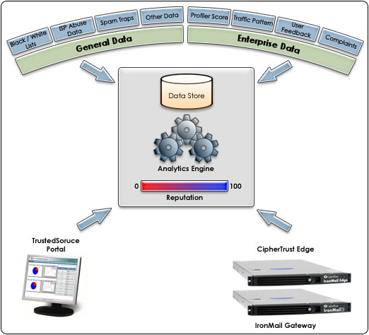
Why is this partnership important to F5?
This is the only solution that enables customers to use their existing BIG-IP’s to gain additional value. It demonstrates the flexibility and value of iRules, and the broad value that BIG-IP can address. It is one more feature that our competitors will struggle to offer, if they can at all.
Why is this partnership important to SC?
SC’s crown jewel is TrustedSource. However they recognize that it is not possible for them to reach as many customers on their own, as they could by partnering with companies like F5 who have an existing customer base and platform footprint. They expect the royalties generated to be significant for them.
Does this partnership have a worldwide impact?

Yes. Our partnership is a global alliance, and MSM is available for sale globally. WHAT ABOUT GLOBAL SUPPORT?
Does Secure Computing have any similar products?
Secure Computing currently sells an appliance that can be installed at the edge of the network, that provides similar functionality to MSM. It does not have the full feature set that BIG-IP has, and does not have the installed-base that F5 has. It is also more expensive for customers to purchase Secure Computing “Edge” than to purchase MSM.
If an MSM opportunity comes up, who can help me?
F5 Sales and SE’s should be able to explain the value proposition of MSM to your customers. In the event that the customer wants to dive into specific details of how TrustedSource compiles its reputation scores, your local Secure Computing rep is available to help.
Who should we contact if we have questions about this?

Alan Murphy, F5 Product Manager: a.murphy@f5.com

