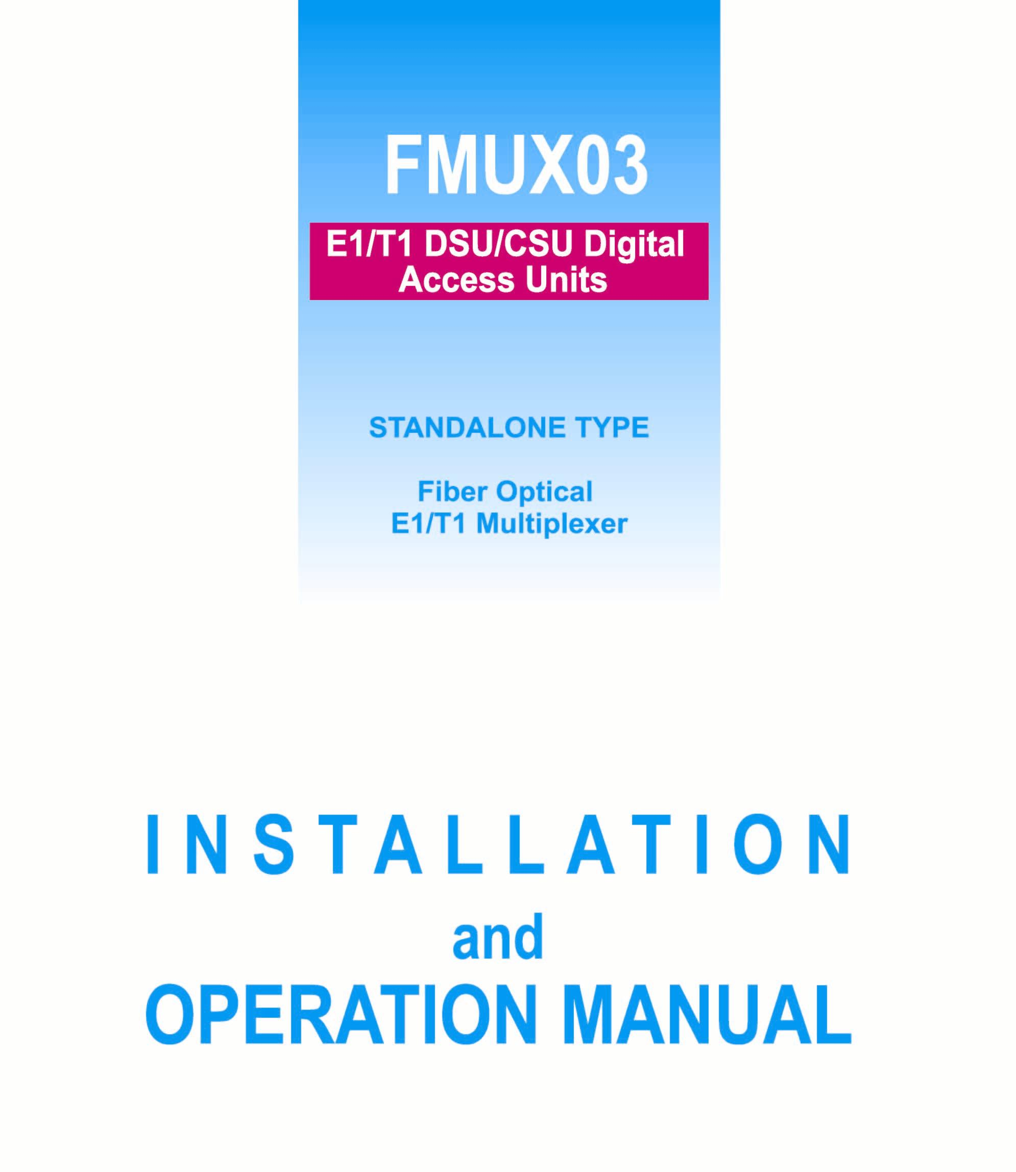


Table of content

Chapter 1 | Introduction.………………………………………………………
 | 1-1 Functional Description.…………….………………………… | 1
 | 1-2 Applications of FMUX03…………………..………………… | 2
 | 1-3 FMUX03 Technical Specification………………..…………… | 3
 | 1-4 FMUX03 Ordering Information….…………………………… | 6
Chapter 2 | Installation…...……………………………………………………
 | 2-1 Description..…………..……………………………………… | 7
 | 2-2 Unpacking.…………………………………………………… | 7
 | 2-3 Site Requirements………………..…………………………… | 7
 | 2-4 Site Selection…………………………………………………. | 8
 | 2-5 DC or AC Electrical Outlet Connection……………..……….. | 8
Chapter 3 | Operating Instructions…………………………………………….
 | 3-1 Front Panel……………………………………………………. | 9
 | 3-2 Front Panel Control and LED Indicator Functions………..…. | 10
 | 3-3 Menu Tree……………….…………………………………… | 12
Chapter 4 | Operating and Setup Instructions………………………………….
 | 4-1 Profile………………………………………………………… | 16
 | 4-2 E1 Configuration………………...…………………………… | 16
 | 4-3 Trunk Link Signal…………………………………………….. | 16
 | 4-4 Optical Module Manual Switch ……………………………… | 16
 | 4-5 Craft Port Operation…………………………………………... | 16
 | 4-6 Connect and setup the craft port……………………………… | 17
 | 4-7 Operating From The Craft Port……………………………….. | 17
Chapter 5 | Diagnostics and Loopback Functions.……….……………………
 | 5-1 General……………………………………………………….. | 25
 | 5-2 For E1 Tributary……………………………………………… | 25
Appendix | A-1. DB25 Pin Assignment for Tributary E1 Line Connection | 1
 | A-2. Pin Assignment for Tributary E1 Pad | 1
 | A-3. Alarm | 2

Chapter 1 Introduction

1-1 Functional Description

The CTC Union’s FMUX03 is a fiber optical multiplexer that integrates 4/8/16 channels of E1 signal into a single optical data stream. It extends the transmission distance up to 80 kilometer. With the optional secondary optical link, FMUX03 provides 1+1 optical line protection. In addition, FMUX03 also provides the standard SNMP interface for Network Management, using Ethernet and PPP ports to connect to central office. User can monitor the FMUX03 through built-in In-band operation channel to reach a remote terminal. Moreover, FMUX03 simplifies testing and maintenance with order wire, allowing communication between local and remote maintenance crews. The FMUX03 provides the telecommunication company a multipurpose and easy to use high quality fiber optics multiplexer.

- The use of FMUX03 with the Smart Agent network interface for ease of network connectivity.
- Provides both 10/100 Base-T and PPP interface to connect SNMP Network Management center interface system.
- Optional secondary fiber link offers 1+1 line auto protection to insure network quality and efficiency.
- In-band operation channel provides the ability to configure, test, and monitor system status and alarm from both local and remote terminal. FMUX03 offers real-time monitoring of the transmission quality to meet the demands of high quality communication.
- E1 signal control calculates error in Path and Line
- The fiber optical interface of E1 communication system complies with the requirement of ITU-T regulatory standards.
- Order wire to assist with remote maintenance, configuration, and testing
- Provides the parity error count for optical interface performance monitoring.
- Operating from dual AC /DC(selectable) power module (co-exist on FMUX03), backup power supply is available.
- Mountable on either 19-inch or 23-inch rack.

1-2 Applications of FMUX03

FMUX03 is mainly used to extend the transmission distance of E1 signal by multiplexing four individual E1 channels into a single optical data stream. As illustrated below, there are three main applications for the use of FMUX03:
- Application 1: FMUX03 integrates 4/8/16 E1 channels into a single optical data stream.
- Application 2: FMUX03 can connect rDSLAM to a remote Central Office
- Application 3: FMUX03 can connect a Base Station (BS) to a Base Station Control (BSC).

Application 1

Application 2

1-3 FMUX03 Technical Specifications
- E1 Interface
- Channel Capacity: 4/8/16 channels
- Bit Rate: 2.048Mbps +/- 50ppm
- Line Code: HDB3/AMI
- Impedance: Balanced 120Ω or Unbalanced 75Ω
- Electrical Interface: Conform with international standards ITU-T
G.703
- Jitter Tolerance: Conform with international standards ITU-T G.823
- Jitter Transfer: Conform with international standards ITU-T G.742
- Test Load Impedance: Balanced 120 +/- 5% Ω resistive or
Unbalanced 75 +/- 5% Ω resistive
- Pulse Shape: Conform with ITU-T G.703 standards
- Nominal peak voltage of mark (pulse): +/- 3.0 Volts
- Nominal voltage of a space (no pulse): +/- 0.3 Volts
- Ratio of the amplitudes of positive and negative pulses at the
nominal half amplitude: 0.95 - 1.05
- Ratio of the widths of positive and negative pulses at the nominal
half amplitude: 0.95 - 1.05
- Nominal Pulse Width: 244ns
- The digital signal presented at the input port shall be as defined above
but modified by the characteristic of the interconnecting pair. The attenuation of this pair shall be assumed to follow a √f law and the loss at the frequency of 1024 kHz shall be in the range of 0 to 6 dB.
- The minimum values for Return Loss is listed below:
Frequency (kHz) | Min. Return Loss Value (dB)
51 ~ 102 | 12
102 ~ 2048 | 18
2048 ~ 3072 | 14

Jitter generation: The jitter of the E1 output signal in the absence of input jitter shall not exceed the following limits in both bands simultaneously. Jitter output should meet the requirement after FMUX03 performs the loopback test without jitter for E1 input signal.
- Connector Type: DB-25 female connector

- Optical Link
    - Wavelength: 850，1310 or 1550 nm MLM Laser diode
    - Number of Optical Link：2 (working and protection link)
    - Output Power: > -12dBm at 62.5/125 (850 nm Laser)
＞-12dBm at 9/125 (1310 nm Laser)
＞-12dBm at 9/125(1550 nm Laser)
    - Receiver Sensitivity: ＞ 0dB (Laser 850nm)
＞-32dBM (Laser 1310 nm or 1550 nm)
    - System Gain: ＞12-14dB (Laser 850nm)
＞20-30dB (Laser 1310nm or 1550nm
    - Fiber type: Single Mode (9/125um) or Multi-Mode (62.5/125um)
    - Connectors: FC/PC , SC or ST

- Alarm Detection and Indication
  - Tributary Interface
      - LOS (Loss of Signal): The loss of E1 signal
      - AIS (Alarm Indication Signal): Alarm indicator
- Optical Interface
      - LOS (Loss of Signal)：The loss of optics signal
      - LCK (Lock): Prevent switching to protect line
      - RDI (Remote Defect Indication): Remote alarm
      - Laser On: Laser On indicator
      - System Power and Control Module: Normal/failure detection
- Alarm Connector
      - DB-9 female connector
      - Connect to an external BUZZER to receive visible and audible alarm.

- Diagnostic capabilities
      - E1 Tributary: Local Loopback, Remote Loopback, and Request
Remote Loopback.
      - Trunk Link: Local Loopback and Remote Loopback
      - ACO: Alarm cut off
      - RST: Reset button

- Configuration
- Use the 3 control buttons and the LCD front panel to configure and monitor the system
- Craft port with DCE appearance
      - Bits per second (baud): 9600bps
      - Parity: None
      - Data Bits: 8 bits
      - Stop Bit: 1
(VT-100 or Emulation Terminal)

- Power
      - DC: -36V ~ -72V
      - AC: 90V ~ 288V(47Hz ~ 63Hz)

- Physical Specifications
      - FMUX03 Dimensions
 | Depth | Width | Height
FMUX03/4 | 220mm | 285mm | 44.5mm
FMUX03/8/16 | 440mm | 285mm | 44.5mm
      - Optical Link: FC/PC or ST,
      - Electrical Link: DB-25 female connector
      - Order Wire: Microphone and headset
      - Network Management Center Interface: RJ-45 and DB-9 connector
      - Alarm Connector: DB-9 connector
- Environment
      - Operating Temperature: 0 ~ 40℃ Indoor Version
0 ~ 60℃ Outdoor Version
-25 ~ 70℃ Storage
      - Humidity: 5 ~ 95%
      - EMI: Comply with CISPR 22 standards A(EN55022) and FCC Part 15 rules.
      - EMS: Comply with EN55082-2 standards
      - Safety: Complies with EN60950 standards

1-4 FMUX03 Ordering Information
Options for Ordering Information

FMUX03-X XX-XXXX X-X-XX-X

Optional Feature
S: Surge Protection
Power Module
AC1: Single 90 ~ 288 VAC power supply
AC2: Dual 90 ~ 288 VAC power supply
DC1: Single -34 ~ -72 VDC power supply
DC2: Dual -34 ~ -72 VDC power supply
AD: AC/DC dual power supply
Fiber Optical Connector
F: FC/PC type fiber connector
T: ST/PC type fiber connector
S: SC/PC type fiber connector
Fiber Optical Module
S: Single OE module
D: Dual OE module
Fiber Optical Wavelength
850: 850nm multi-mode
1310: 1310nm single-mode
1550: 1550nm single-mode
Interface module
E1B: 120 ohm, balanced
E1U: 75 ohm, unbalanced
T1: 100 ohm
V35: V.35 data port (single port only)
Port Number
4: 4 ports
8: 8 ports
16: 16 ports

Chapter 2 - Installation

2-1 Description
This chapter provides the information needed to install FMUX03. It is important to follow the installation instruction to insure normal operation of the system and also to prevent damage due to human error.

2-2 Unpacking
If there is a possibility for future relocation of the FMUX03 unit, please save the cartons and protection packaging material. The following items are shipped with your FMUX03:

- One FMUX03 User’s Manual
- One FMUX03 Unit
- Depends on what was ordered, either DB-25 wire wrapped adaptor or DB-25 Mini Terminal Block

Please carefully unpack and inspect the unit and accessories for damaged and missing parts. Contact our nearest sales representative or our company directly if you suspect any damaged or missing parts. Improper handling during shipment may cause early failure.

2-3 Site Requirements
The FCC requires telecommunication equipment to withstand electrical surge that may result from lighting strikes. FMUX03 has been tested and found to comply with the FCC requirement. Users should follow the precaution below to insure the safety and minimize the risk of damage to the equipment:
- Make sure that the power outlet is properly grounded. Please refer to article 250 of the National Electrical Code (NEC) Handbook.
- Proper grounding should include a minimum of:
- A grounded rod buried outside the building at least 8 feet (2.44 meters) deep.
- It is preferred that the building uses metal water pipe and cooper connector at the joint.
- Any device connected to FMUX03 either directly or indirectly should use the same set of power outlet.

2-4 Site Selection
For best performance, install the FMUX03 within 50 feet (656 meters) from the data terminal equipment and 6 feet (1.83 meters) from the AC power outlet. To allow easy access to the equipment, leave at least 36 inches (90 cm) clearance in front and at least 4 inches (10.2 cm) at the rear.

To avoid overheating, leave at least 1 inch (2.5 cm) on either side of FMUX03. Also, do not stack another equipment on top of FMUX03.

2-5 AC or DC Electrical Outlet Connection
For safety and to prevent damage to FMUX03, make sure that the power requirement matches those of your electric outlet. Connect power to FMUX03 and power on the equipment.

Chapter 3 – Operating Instructions

3-1 Front Panel
There are four parts to the front panel of FMUX03:

  - Fiber Optics Connectors and Indicators: Two sets of optics transmit/receive and indicators, one working and another as protect. Notifies user of a problem such as LOS (Loss of Signal) and Laser LED (LSR).
  - Alarm LED Display: Notifies users of a problem such as LOS (Loss of Signal) and AIS (Alarm Indication Signal) for each of the four E1 channels.
  - LCD Control Buttons: The three buttons, ▲, ▼, and are used for system configuration and for the loopback test.
  - Order Wire: User can connect FMUX03 to a headset and microphone for ease to remote configuration and testing.

Each of the LED indicators is described below in detail:

Front panel
LED Display

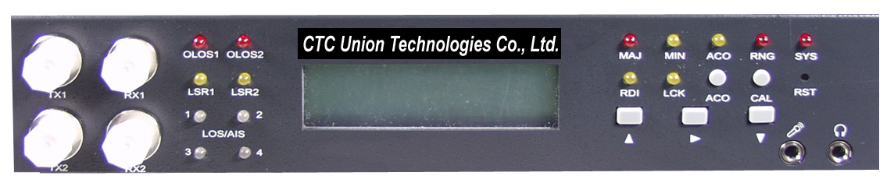

Fiber Optical Connector
(Working and stand by)
LCD Control Button
Order
Wire

3-2 Front Panel Control and LED Indicator Functions （refrence appendix）

# | Control or LED Indicator | Function
1 | OLOS1  OLOS2  LSR1/LSR2 | Red light when there is a loss of input signal  Orange light when there is a loss of output signal  Yellow light signals an alarm in Laser sending out energy normally
2 | LOS/AIS | Red light when there is a Loss of Signal (LOS)  Yellow light when received an Alarm Indication Signal (AIS)
3 | MAJ | Red light when there is a Major Alarm present
4 | MIN | Yellow light when there is a Minor Alarm present
5 | RNG | Red light when connected to the remote terminal.
6 | SYS | System normal or System failure
7 | RDI | Remote Defect Indication;  Indicates a failure in the remote terminal
8 | LCK | System Lock; Locks the system if switched to protect line 6 times within 10 minutes
9 | ACO | Alarm Cut Off; Yellow lights when the ACO button is pressed to manually disable the audible alarm when a problem occurs.  If any newer alarm is reported after the ACO button has been pressed, the external alarm will activate again.
10 | CAL | Order wire
11 | RST | Restart the system
12 | ▼  ▲ | These three buttons serve as the control and configure FMUX03

DB-25 pins female for E1 interface
Power Switch

背板(Rear panel)

Alarm (DB9)
LAN PPP
AC & DC Power
Terminal Connector
Rear panel
- E1 I/O: DB25 female connector for input/output of E1 signal
- Alarm: DB9 female connector; Connect to an external BUZZER to receive visible and audible alarm.
- Terminal Connector: LAN/PPP connector to remote terminal using RJ45.
- Power Switches: On/Off switch for FMUX03
- There are 5 different power supply combinations with the DC/AC dual module power supple: AC only. DC only, dual AC, dual DC, both AC and DC (Reference to Order Information)

  - Menu Tree
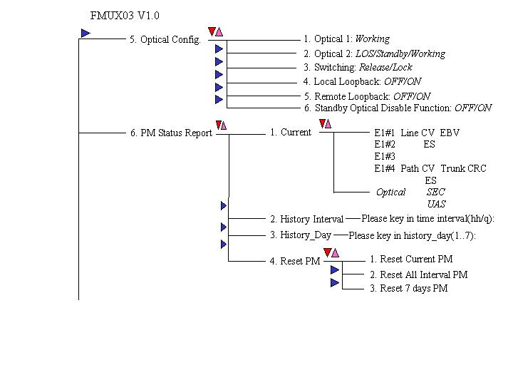
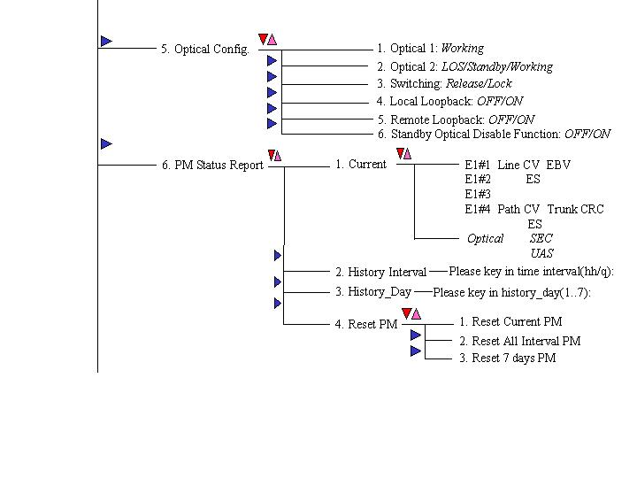
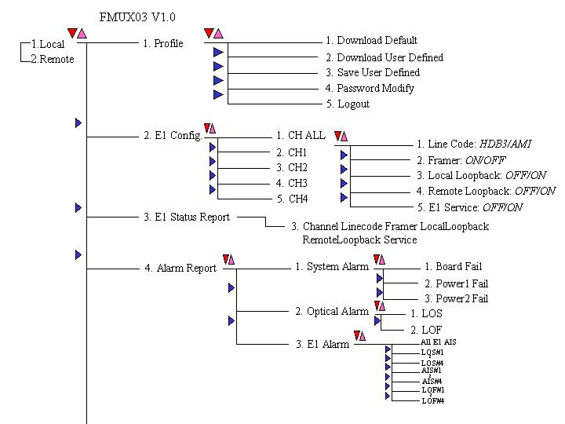
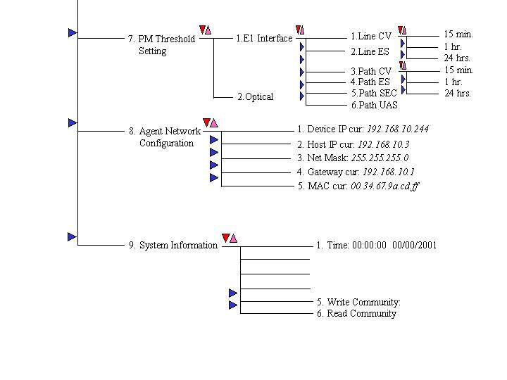

Chapter 4 - Operating and Setup Instructions

FMUX03 provides easy to use LCD control for easy configuration, maintenance, and testing. Button functions are as follows:
Menu select
▲ Go back to the upper level of the menu
▼ “Enter” key to go to a sub-menu

4-1 Profile

Download and Save Profiles:
If the user selects the factory default profile, the system will restart before downloading the factory default profile.

User can configure E1 Line Code(HDB3/AMI), and Loopback test. After selecting the “user_defined” option, the system will automatically restart. The system will then download the user custom profile.

Modify Password:

To prevent unauthorized login, user must enter a set of password to login to the system.
The password for FMUX03 is a combination of the buttons below, from left to right:

Button | Up ↑ | Right → | Down | Up ↑
Password | U | R | D | U
User can change the password using this function after verifying the current password. Password can also be changed from the craft terminal using the same procedure. Note that the password for operating the craft can be different from LCD menu driven is needed.
Note: In case the user forgets the login password, the universal password for FMUX03 “1234” can be used.

4-2 E1 Configuration

There are two types of loopback tests for E1 configuration: Local Loopback and Remote Loopback. To perform the test on an individual E1 channel or all channels, select the function CH#(n) or CH#All.

Note: Refer to Chapter 5 for detailed information on Diagnostics and Loopback Functions.

4-3 Trunk Link Signal

There are two types of loopback tests for the Trunk Link Signal: Local Loopback and Remote Loopback.

Note: Refer to Chapter 5 for detailed information on Diagnostics and Loopback Functions.

O/E Module status can be obtained from this current menu:
- Under normal operation, LCD display shows that the working O/E module as “Working” and the backup O/E Module as ”Standby.”
- If FMUX03 detects a Loss of Signal, the LOS light will be lit and the LCD display will show that there is a Loss of Signal.

4-4 Optical Module Manual Switch

Users can manually which between O/E module 1 and O/E module 2 if a secondary O/E module is installed on the FMUX03.

4-5 Craft Port Operation

Craft port allows user to monitor and configure FMUX03 through a remote terminal emulator, such as VT100.

4-6 How to connect and setup the craft port

- Connect the craft port to a remote terminal using DB-9 cable.
- VT100 terminal settings:
Bit Rate: 9600bps
Data Bit: 8 bit
Parity: No Parity
Stop Bit: 1 Stop bit

Set the emulation mode to”VT100” or “Auto Detect”.

4-7 Operating From the Craft Port

After properly connecting the craft port to a terminal, the system will prompt the user for password. The universal password is “1234.”
The figure below is a screenshot of the login terminal screen:
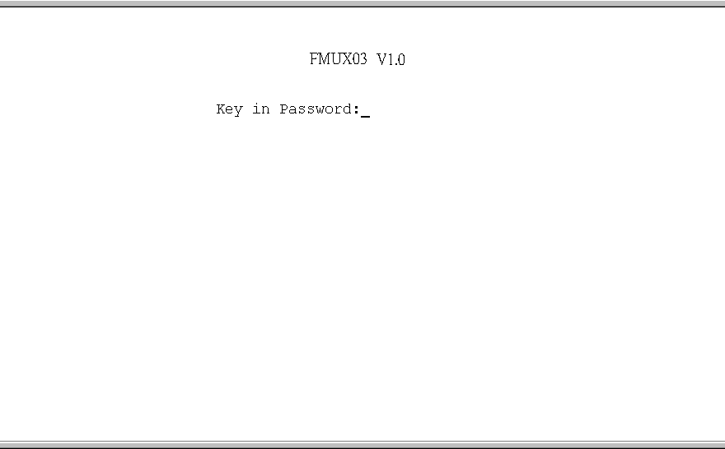

User can access a function by typing its corresponding number into the remote terminal. To go back to the previous menu, press the ‘Backspace” key. Refer to the Menu Tree for navigation.

After entering the remote terminal screen, user can select Local Side operation and Remote Side operation for configuration, loopback, and monitoring of the FMUX03.

Local/Remote

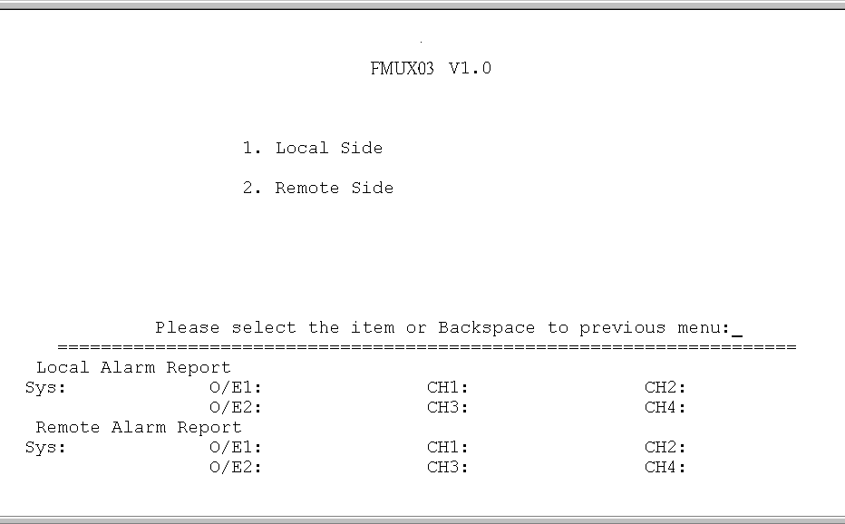

After entering the main menu, select of the nine functions:
- Profile
- E1 Configuration
- E1 Status Report
- Alarm Report
- Optical Configuration
- PM Status Report
- PM Threshold Setting
- Agent Network Configuration
- System Information

Main Menu

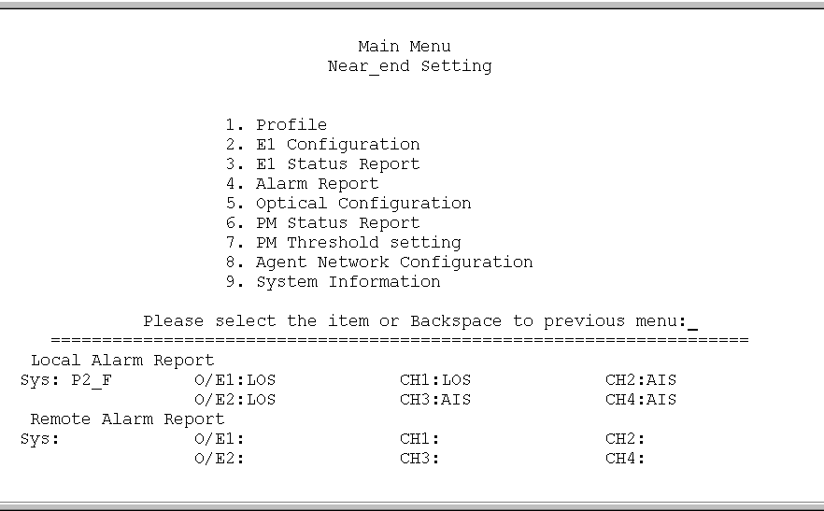

（1）－1設定值

E1 configuration

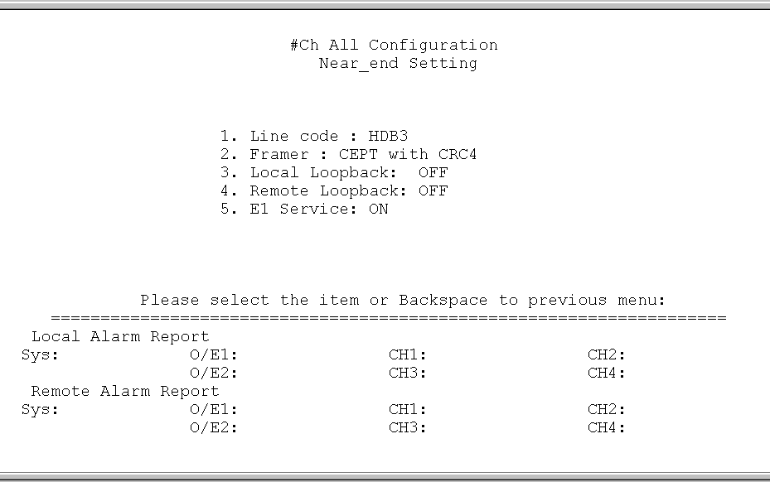

Alarm report

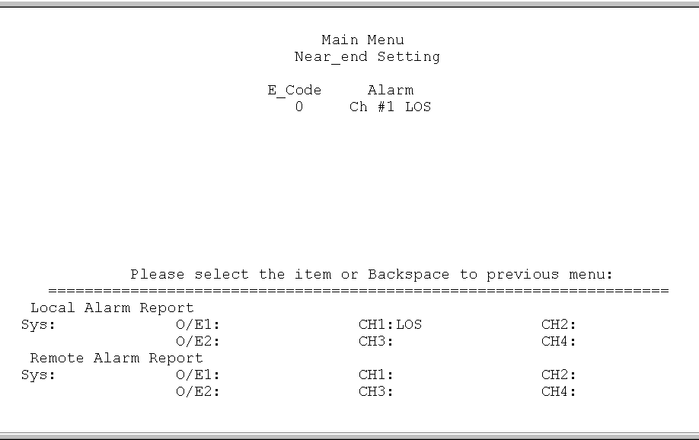

Optical configuration

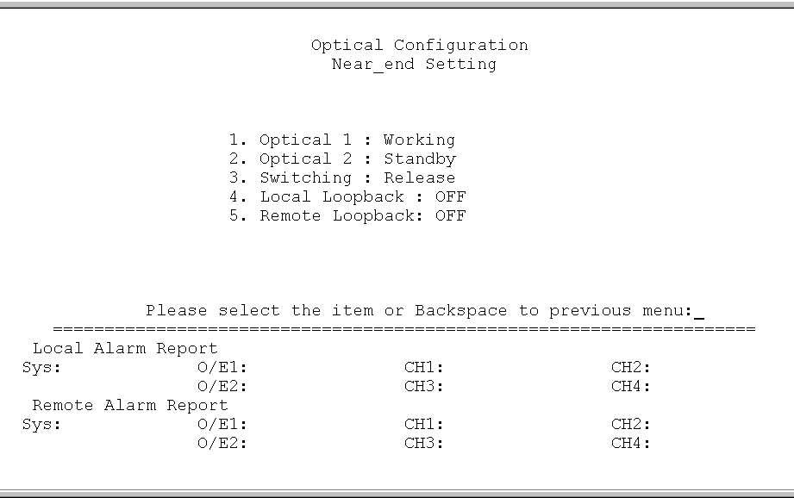

PM report

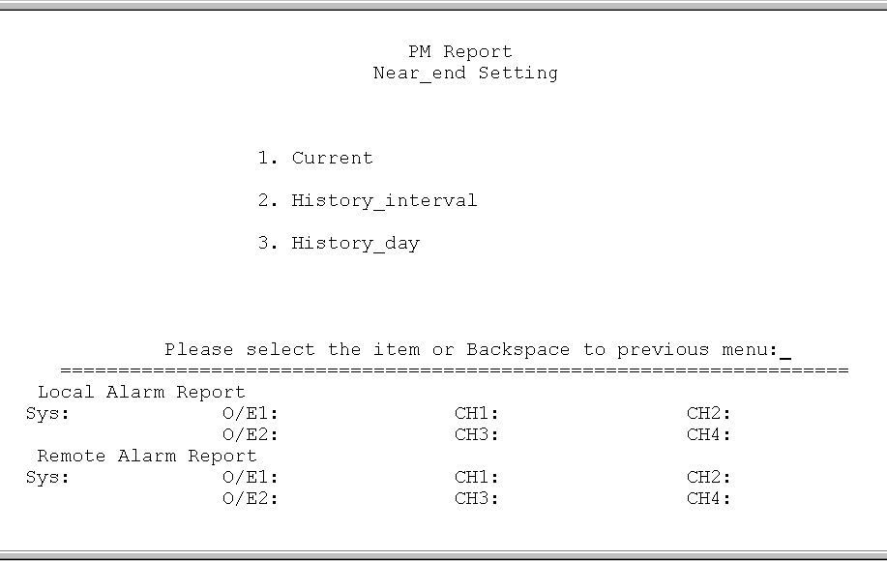

PM history report

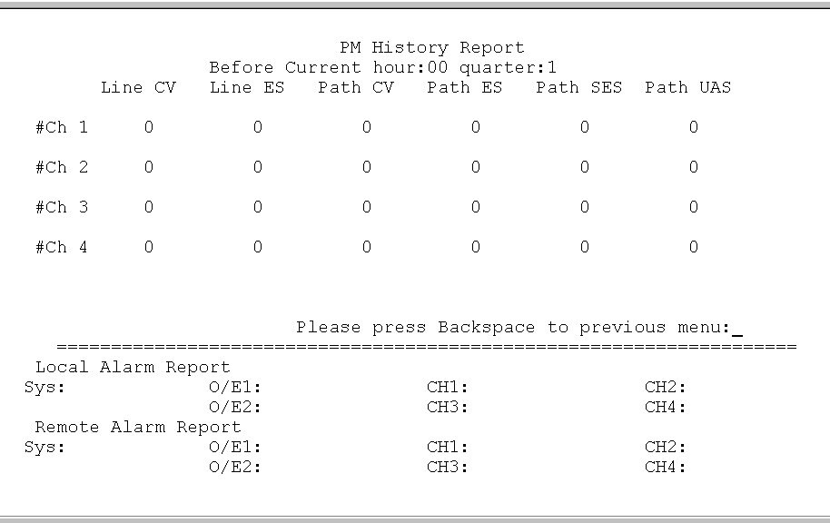

PM threshold setting

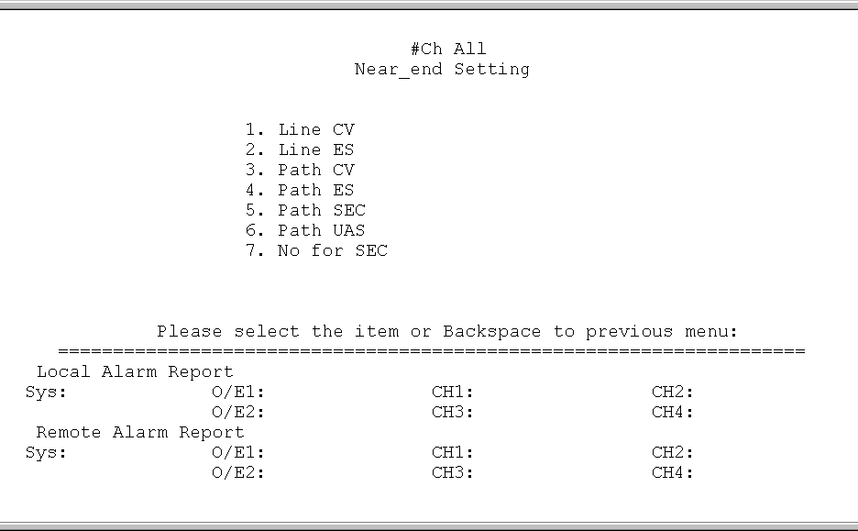

PM report setting

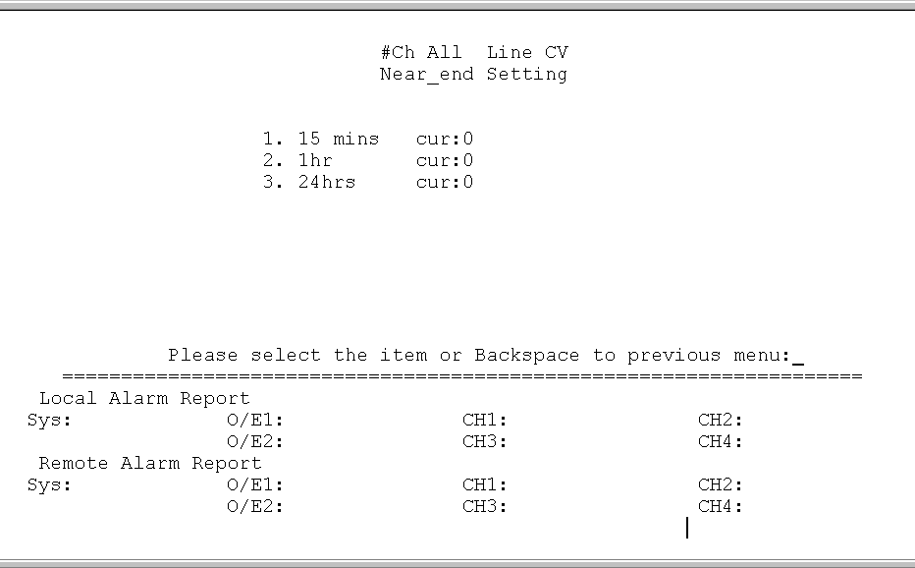

Agent network configuration

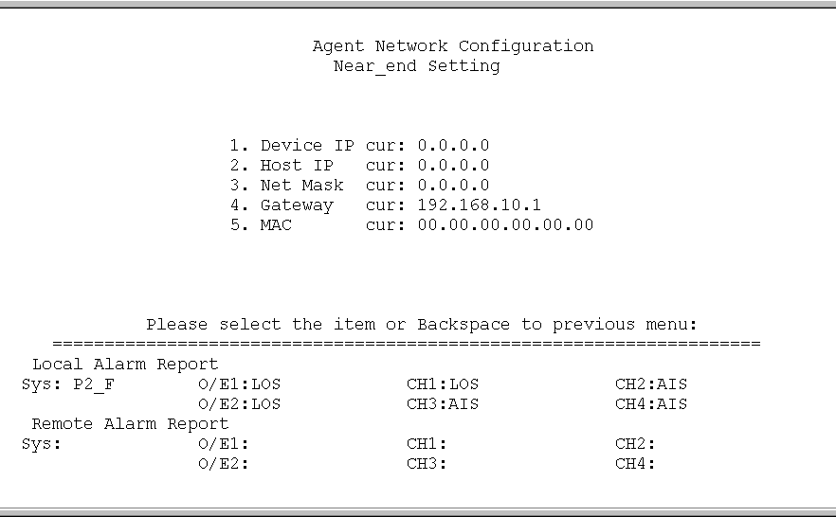

System information
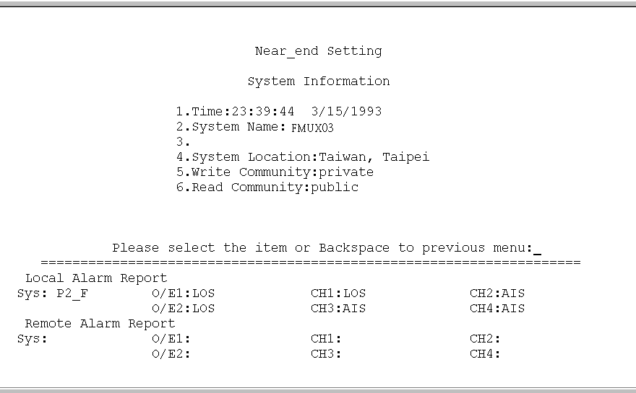

Chapter 5 - Diagnostics and Loopback Functions

5-1 General Information
This chapter contains detailed information on the diagnostics and the loopback tests of the FMUX03 fiber optics transmission equipment. User can activate the loopback function to diagnose the full service.

5-2 Loopback Functions for E1 Tributary
There are two types of loopback functions for the E1 Module: Local Loopback and Remote Loopback. User can select whether to diagnose a specific channel or all channels under the “E1 Configurations” options.

Figures below illustrates the concepts of the loopback function:

- Local Side Loopback:

Local Side Loopback tests the path between local E1 and remote E1.

- E1 Local Loopback

- E1 Remote Loopback

3.Optical Local Loopback

4.Optical Remote Loopback

- Remote side:
1. E1 Local Loopback

2. E1 Remote Loopback

3.Optical Remote Loopback

4. Optical Local Loopback

APPENDIX

A-1 DB25 Pin Assignment for Tributary E1 Line Connection

A-2 Pin Assignment for Tributary E1 pad

A-3 Alarm
Alarm Status |  | LED sign | MAJ | MIN
Single OE | OLOSW | OLOS1 | *
Single OE | OLOSP | OLOS2 | *
Dual OE | OLOSW | OLOS1 |  | *
Dual OE | OLOSP | OLOS2 |  | *
Dual OE | OLOSW & OLOSP | OLOS1, OLOS2 | *
Dual  Power | PWRF1 |  |  | *
Dual  Power | PWRF2 |  |  | *
ELOS1 |  | ELOS | *
ELOS2 |  | ELOS | *
ELOS3 |  | ELOS | *
ELOS4 |  | ELOS | *
EAIS1 |  | AIS |  | *
EAIS2 |  | AIS |  | *
EAIS3 |  | AIS |  | *
EAIS4 |  | AIS |  | *
OAIS |  | AIS |  | *
ELOF1 |  |  | *
ELOF2 |  |  | *
ELOF3 |  |  | *
ELOF4 |  |  | *
OLOF |  |  | *
LOC_8M |  | SYS | *
LOC_2M |  | SYS | *
LOC_8RM |  | SYS | *
ERDI |  | RDI |  | *
ORDI |  | RDI |  | *


Fiber Optical Multiplexer Series

CTC Union Technologies Co., Ltd.
Far Eastern Edison Science and Technologies Center
(Nei-Hu HI-TEC Park)
6F-3, Lane 360, Nei-Hu Road, Section 1
Nei-Hu, Taipei, Taiwan
Phone:(886) 2.2659.1021 (Rep) Fax:(886) 2.2799.1355
E-mail:mailto:info@ctcu.com
http://www.ctcu.com

