Cable Type: Duct cable - non metallic central strength member, stranded loose tubes, filling, wrapping, peripheral strength members, PE sheath

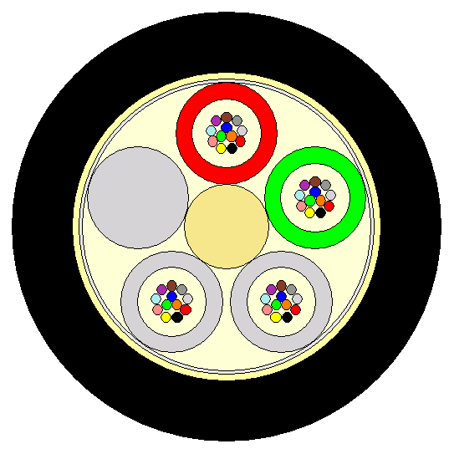  - not to scale -  figure shows: cable with 48 fibres |  | - Central strength element (CSM): FRP  - Loose tubes: tubes of thermoplastic material filled with thixotropic compound, containing up to12 fibres  - Cable core: 4 loose tubes and 1 filler element are SZ stranded around the central element.  The interstices of the cable core are filled with high grade cable filling compound.  - Core wrapping: plastic tape  - Strain bearing elements: aramide yarns  - Sheath: PE, black, nominal radial thickness: 1.5 mm, two rip cords beneath the sheath

Cable Dimensions and main mechanical characteristics
no. of loose tubes x fibre count per tube | fibre count | cable O.D. | cable weight, approx. | Tensile performance installation / operation | Bending radius installation / operation | CSM O.D. | Loose tubes O.D.
 |  | [mm] | [kg/km] | [N] | [mm] | [mm] | [mm]
4 x 12 | 48 | 11 | 95 | 1900 / 650 | 220 / 165 | 2.1 | 2.5

Mechanical Properties and Delivery Conditions
standard delivery length | 4 km | transport and storage | -40°C up to +70°C
 |  | installation | -5°C up to +50°C

Main Mechanical and Environmental Characteristics
Test | Test Standard | Specified Value | Acceptance Criteria
Tensile performance | EN 187000, 501 | kilometric weight * 2 [N] =T_{max}  kilometric weight * 2 [N] / 3 =T₀ | Δα reversible  Δα ≤ 0.05 dB/100 m
Crush | EN 187000, 504 | 1.5 kN / 100 mm | Δα ≤ 0.05 dB
Impact | EN 187000, 505 | 10 Nm, r=300 mm, 3 impacts | Δα reversible
Torsion | EN 187000, 508 | 1 m, ±180°, 100 N | Δα ≤ 0.1 dB/fibre
Cable bend | EN 187000, 513 | 15 x cable outer diameter, 5 turns | Δα ≤ 0.05 dB
Temperature cycling | EN 187000, 601 | -10°C ... +50°C  -20°C ... +70°C | Δα ≤ 0.05 dB/km  Δα ≤ 0.1 dB/km
Water penetration | EN 187000, 605 | 3m cable, 1m water, 24h | no water leakage

Identification:
outer sheath marking |  | identification of loose tubes and fillers within cable core
The outer cable sheath is marked in white with a sequential length marking in regular intervals of 1 m.  Remark: Additional markings upon request. |  | 1. tube: red (marker)  2. tube: green (direction)  all other tubes: white  filler elements: nature  Remark: Other colour codes upon request.

identification of fibres within loose tube

fibre no. | colour of fibre | fibre no. | colour of fibre | fibre no. | colour of fibre
1 | blue | 5 | grey | 9 | yellow
2 | orange | 6 | white | 10 | violet
3 | green | 7 | red | 11 | pink
4 | brown | 8 | black | 12 | turquoise

