
SAN MASK Guide
1. Preface :
SAN Mask (LUN Masking) is used for as a Network identify tool (similar to MAC Address of Network Card). It uses World Wide Name(WWN) of Fibre Card to identify, so you would not find identical WWN on any two fibre cards. To explain its purpose in simplified terms is that under SAN architecture, the setting of one storage can only be detected by one (or more) Host, and the storage would not be detected without the other Hosts.
2. Functions:
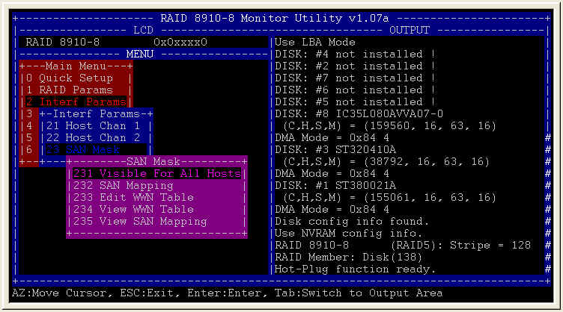
Figure 1.
Figure 1. shows the new added menu tree of SAN Mask , new added functions include 231 Visible For All Hosts , 232 SAN Mapping , 233 Edit WWN Table , 234 View WWN Table , and 235 View SAN Mapping , we will show you the new added functions.
231 Visible For All Hosts:
This sub-menu include 2311 Port1 and 2312 Port2 , that Port equal Host Channel , “ENABLE” means that all Hosts can detect it , and ”DISABLE” means that all Hosts can’t Detect it, if SAN Mask function is to be selected, the menu item must be on ”DISABLE”. (Figure 2.)
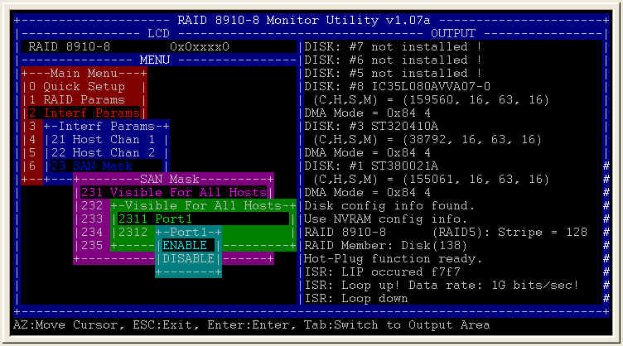
Figure 2.
232 SAN Mapping:
This sub-menu is used for mapping different LUN to different Host (see Figure 3.、Figure 4.). For example , if you create one Array and split it to 8 Slices, and each Slice mapping to difference LUN , now we have 8 LUN, then different LUN does mapping to different Host , now each Host will separate mapping to difference slice, after connecting to Fibre Switch, each Host will recognize difference slice.
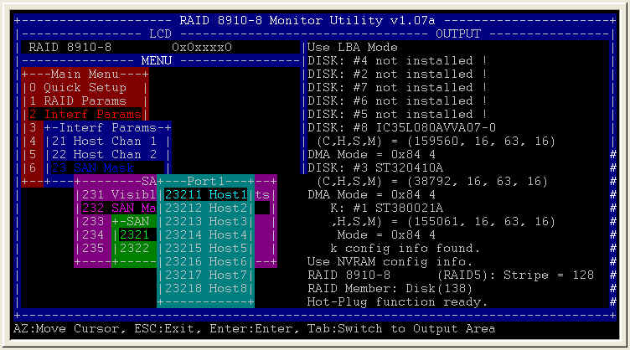
Figure 3.
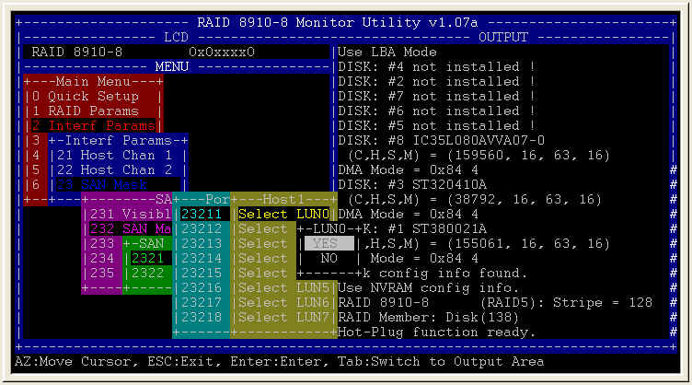
Figure 4.
233 Edit WWN Table:
This function is setting World Wide Name of Fibre Card to Controller , if no values are entered, the default value is 0000000000000000. (Figure 5.)
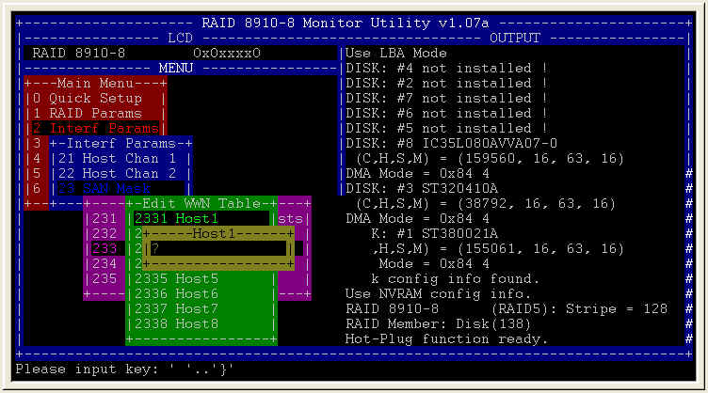
Figure 5.
234 View WWN Table:
Figure 6. shows the result of executing this sub-menu , on the right side 200000E08B00172F is the World Wide Name of this Fibre Card.
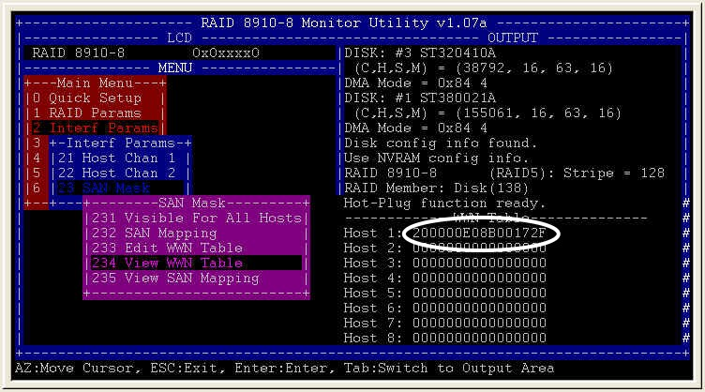
Figure 6.
235 View SAN Mapping:
Figure 7. shows the result of executing this sub-menu, the OUTPUT “Y” on the right hand side represents LUN 0 mapping to Host 1, and the other “N” means there was not any mapping assigned.
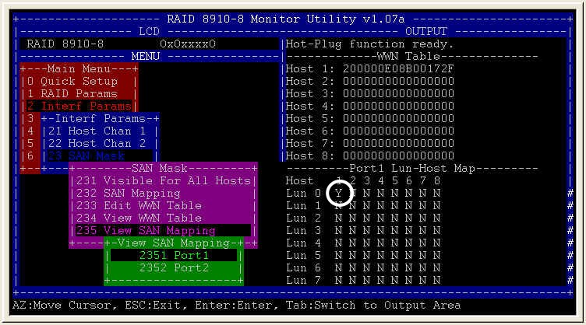
Figure 7.
3. Applications:
Before using SAN Mask, you should find out the World Wide Name of Fibre Card. Different venders have their specific ways of finding out the World Wide Name of Fibre Card, but usually you will find it under Fibre Card’s BIOS, Figure 8. shows QLogic ISP2100 Fibre Card as an example, the circled value is the World Wide Name of Fibre Card 。
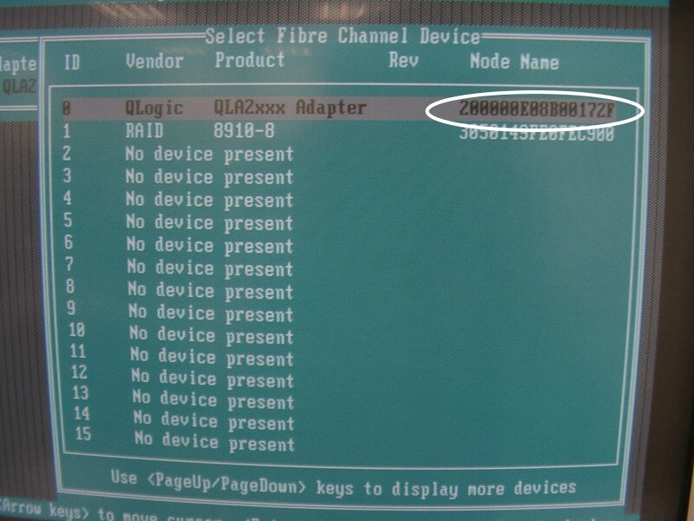
Figure 8.
3-1 One LUN Mapping to one Host:
Setting one LUN, and Mapping to one Host, executing SAN Mapping after the setting is done, view OUTPUT and make sure the setting is correct (see Figure 9.) The result will show that a LUN is detected after turning on Host detect (see Figure 10.).
Figure 9.
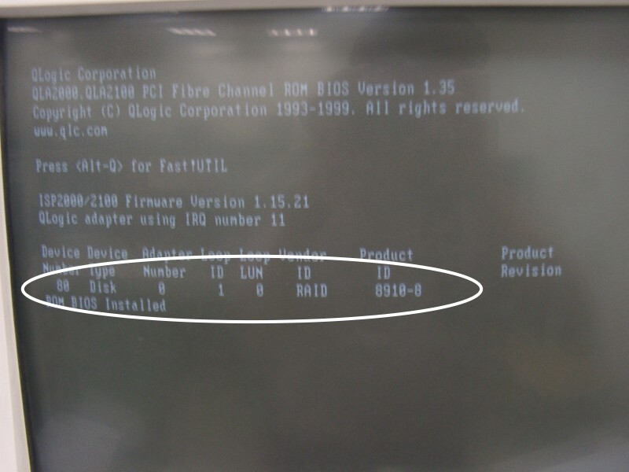
Figure 10.
3-2 Three LUN Mapping to one Host:
Setting three LUN , and Mapping to one Host , executing SAN Mapping after the setting is done, view OUTPUT and make sure the setting is correct (see Figure 11.), the result will show that 3 LUN are detected after turning on Host detect (see Figure 12.).
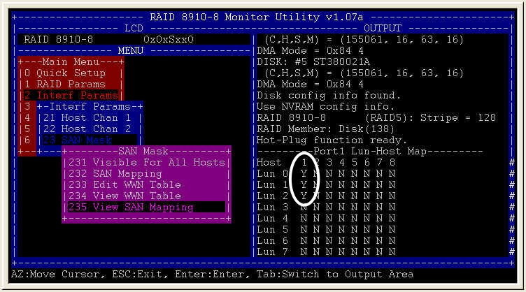
Figure 11.
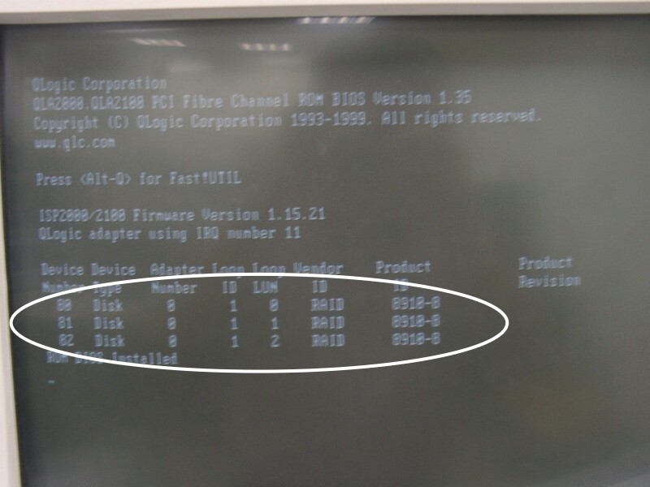
Figure 12.
3-3 Summary :
SAN Mapping can be used to test if SAN Mask is fully functional, for example, if you split one Array to 3 Slices, and each Slice does mapping to Host 1, the Host will detect 3 LUN or split to 3 Slice. On the other hand, if only mapping one Slice to Host, the Host only will detect one LUN. By using this method you can test whether SAN Mask is working or not. Another method that can be used to test if San Mask if working properly is to use Fibre Switch to connect several Host and enter the World Wide Name of all Host while separating mapping to all Host, and see if each Host can detect all of the LUN of mapping.

