
- Executive summary
We testing filer server performance on AXUS DemonNAS Series server. We used NetBench 7.0.3 filer server performance benchmark software to provide the load and throughput on the server.

To generate the load for the test, we configured a network testbed consisting of 12 clients(1 Pentium 4 2.4 GHz, 512 MB DDR, Intel(R) PRO/1000 MT Desktop Adapter). And the NetBench server (1 Pentium 4 2.8G 512 MB DDR, Intel(R) PRO/100 M Desktop Adapter) also direct connect to switch. We used two Gigabit Switchs to building testing network environment. The network topology is as below.

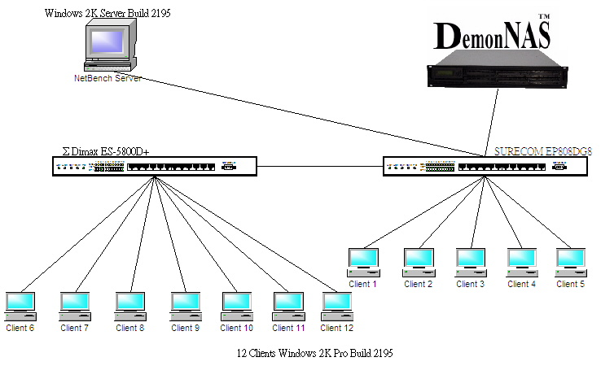
Figure 1 Network topology
- Performance report
We run our test on three types of RAID systems, RAID 5 , RAID 1 and RAID 0. The speeds of all clients connected to network are 100 M/b and NetBench also connected to network using 100 M/b link speed. DemonNAS also direct connected to network using its Gigabit Ethernet port 1.
■RAID 0 ■RAID 1 ■RAID 5 ■RAID 5 with cache
Figure 2. RAID types max peak throughput
Figure 2 show out the peak throughput value in each RAID tested.It had the great value in RAID 5 with cache.
■RAID 0 ■RAID 1 ■RAID 5 ■RAID 5 with cache
Figure 3 Total throughput
Figure 3 show out the total throughput of each type raid systems. Our results are point out the RAID 5 with cache had the great performance.
■RAID 0 ■RAID 1 ■RAID 5 ■RAID 5 with cache
Figure 4. Average response time
Figure 4 show out the average response time on each test suite.

■RAM 256Mb ■RAM 512Mb
Figure 5. Memory size
Figure 5 show out the performance with memory size. When the clients get more and more, the bigger size of memory had more performance.

